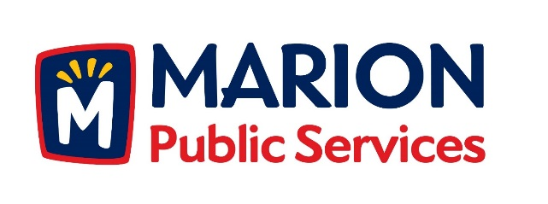

CITY OF MARION PUBLIC SERVICE BOARD
AGENDA
Noon
November 10th, 2015

- Approval of September Minutes.

- Motion to Approve House Pickup Request.
  - Warnke-1155 28th Street

3. Discussion on Public Services site plan and development.

4. Discussion on Solid Waste fees.

5. Board Member Appointments

6. Old Business/New Business.

7. Adjournment.

