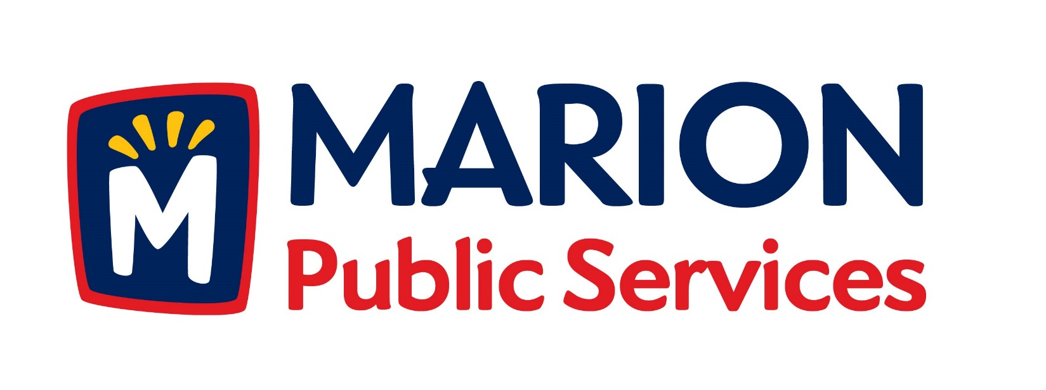
Minutes
Public Services Board
City of Marion
Tuesday, November 10, 2015

Present: Craig Adamson, Tom Padley Mark Morgan, Colleen Prokop, and Kevin Morgan
Staff: Ryan Miller and Diane Toy

- Approval of August 2015 Minutes.
- Motion to Approve house Pickup Request:
  - Warnke – 1155 210th St
- Discussion on Public Services site plan and development.
- Discussion on Solid Waste fees.
- Board Member Appointments.
- Old Business/New Business.
- Adjournment.

Minutes
Public Services Board
City of Marion
Tuesday, November 10, 2015
Continued

ITEM 1 Approval of September 2015 Minutes
Craig Adamson called to order the regular meeting of the Public Service Board on Tuesday, November 10, 2015 at 12:13 PM. A motion to approve the September 2015 minutes was made by Mark Morgan, seconded by Colleen Prokop, approved by all, Motion carried.

ITEM 2 Motion to Approve House Pickup
A request for a house pickup at 1155 28th St., resident is elderly and has health issues and lives alone. Resident has request that this resident become a house pick up. A motion was made by Tom Padley, seconded by Kevin Morgan, all members agreed, Motion carried.

ITEM 3 Discussion on Public Service site plan and development
Ryan updated the PS Board about the site plans for the new facility: One is a new building on the new property behind our current facility, second one is use part of the existing building and re-steel, re-roof and make needed updates and additions to existing building. A new building will get us by for the next 30 years, with a goal to plan a low maintenance facility. There is lots of outside contractor interest in the new Eco-Park development, need to take our time and make sure everything is in place and in the best interest of the citizens. Main building would have 40 foot parking spaces, 40 foot drive lane and another 40 foot parking space. Looking at different designs for the salt building, need to find the most cost efficient design. A motion was made by Mark Morgan for Ryan to move forward with planning and report back to the PS Board, seconded by Colleen Prokup, and all Board members are in favor, Motion carried.

Minutes
Public Services Board
City of Marion
Tuesday, November 10, 2015
Continued

ITEM 4 Discussion on Solid Waste fees
Ryan updated the PS Board about the increase in dumping fee for recycling at the landfill, this is the biggest fee increase issued by the Solid Waste Agency, because the sale on recycle goods is at a low. Residents are not required to recycle, but that would increase the tonnage of garbage being dumped into the landfill, we are passing on the cost increase to residents. A motion was made by Mark Morgan, seconded by Colleen Prokup, and all Board members are in favor, Motion carried.

ITEM 5 Board Member Appointments

The following PS Board member’s terms are up at the end of the year:

Craig Adamson – 12/31/15
Kevin Morgan – 12/31/15

Both members would like to continue to serve on the PS Board for another 2 years.

Minutes
Public Services Board
City of Marion
Tuesday, November 10, 2015
Continued

ITEM 6 Old Business / New Business
Old business: 1204 Building – they have cleared out the alleyway but the sidewalk is still blocked, Mark Morgan wanted to know if anything was being done. Ryan did not know the answer to that, not a Public Service item.
New business: New council member Will Brandt filling Cody’s old ward will be sworn in at the 11/19/15 City Council meeting. The new mayor will be Nick Abou-Assaly will take office in January 2016.

ITEM 7 Adjournment
Meeting was adjourned at 1:33PM by Craig Adamson. A motion was made by Tom Padley, seconded by Mark Morgan, and all Board members are in favor, Motion carried.

Next PSB meeting is scheduled for Tuesday, December 8, 2015 at noon.

Respectfully submitted by:

____________________
Ryan Miller
Public Service Director

RM/dpt

