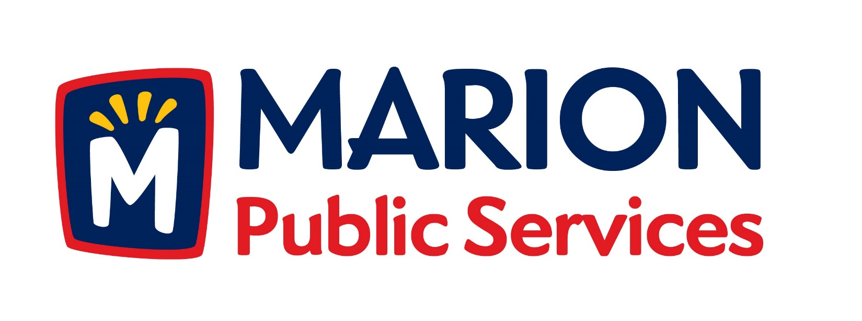
Minutes
Public Services Board
City of Marion
Tuesday, July 14, 2015

Present: Mark Morgan, Colleen Prokop, Tom Padley and Kevin Morgan
Absent: Craig Adamson
Staff: Ryan Miller, Diane Toy

- Approval of June 2015 Minutes.
- Motion to Approve house Pickup Request:
  - Knapp – 1125 Elim Drive
- Discussion Regarding No Fault Sewer Backup Program.
- Discussion Regarding Vacated Premise Policy.
- Discussion Regarding 501c Organization.
- Discussion Regarding Refuse Container Program.
- Old Business/New Business.
- Adjournment.

Minutes
Public Services Board
City of Marion
Tuesday, July 14, 2015
Continued

ITEM 1 Approval of June 2015 Minutes
Mark Morgan called to order the regular meeting of the Public Service Board on Tuesday, July 14, 2015 at 12:10 PM. A motion to approve the June 2015 minutes was made by Colleen Prokop, seconded by Kevin Morgan, approved by all, Motion carried.

ITEM 2 Motion to Approve House Pickup
A request for a house pickup at 1125 Elim Dr, resident is elderly and has health issues and lives alone. A motion was made by Tom Padley, seconded by Colleen Prokop, all members agreed, Motion carried.

ITEM 3 Discussion Regarding No Fault Sewer Backup Program
Ryan updated the PS Board about sewer backups, if we know about it and ignore it we are liable. The City of Marion would like to set up a No Fault Sewer Backup Program that may offer some help to residents, but each claim would have to be reviewed by the Compensation Review Committee. We must notify the DNR after every sewer backup. The City of Marion is looking to identify problem areas and looking at other cities to see how they are dealing with the situation. Some cities are installing or having back flow meters installed as part of the program (included in the total compensation). The second part is to remove sump pumps from the sanitary sewer lines. A question was asked about how would the City of Marion cover the cost of this program, the money could come from the sanitary sewer fund or the replacement fund. A motion was made to move forward by Mark Morgan, seconded by Tom Padley, and all Board members are in favor, Motion carried.

Minutes
Public Services Board
City of Marion
Tuesday, July 14, 2015
Continued

ITEM 4 Discussion Regarding Vacated Premise Policy
Ryan updated the PS Board about the policy for vacated premise can now stop paying for solid waste if they will be gone for 90 days or more/ The Water Department is getting new software and this exemption will be hard to track and maintain. The service cannot be turned off prior to the 180 days, unless they turn off the water then solid waste services can be stopped at the same time. They will have to use the attached form that was approved by the PS Board, the PS Board will make hardship or medical wavier once a written request has been received. A motion was made by Colleen Prokop and seconded by Tom Padley and all PS Board members are in favor. Motion carried.

ITEM 5 Discussion Regarding 501c Organization
Ryan updated the PS Board about how Public Service employees do a lot of volunteer activities within the community outside the Public Services primary role. We are looking into a flag program during certain holidays and city events. We are looking at opportunities for fund raising and external funding to promote and fund some of these programs. Ryan would like to have the PS Board to serve as the oversite for the 501c program to review and recommend programs for the PS department staff who are associated with the program. PS Board members can participate in any of the programs. A motion to move forward was made by Colleen Prokop and seconded by Tom Padley and all PS Board members are in favor. Motion carried.

Minutes
Public Services Board
City of Marion
Tuesday, July 14, 2015
Continued

ITEM 6 Discussion Regarding Refuse Containers Program
Ryan updated the PS Board on the current Solid Waste program that we use now and that we will be collecting solid waste manually for now. We now issue 1 recycle bin to each new construction. Ryan has talked to the manufacturer of the bins – Rehrig and they will print anything on the bin and any of their standard colors, and they are guaranteed for life. Ryan is looking into selling garbage cans at a later date, or do we issue a garbage can to new construction? We need to look into the program more and possibly do a trial program. Ryan wants to make sure everything is nice and clean on garbage day and keep on encouraging the residents to recycle more.
Ideas for colors are Blue – recycle, Red or Black – Garbage and Green – YW
Can have the city’s logo on the cans.

Tom Padley left at 1:05PM.

ITEM 7 Old Business / New Business.
Ryan talked about Coe Collage just completed the testing of the IC watershed. Ryan would like to convert the IC watershed into a recreational area , he is just waiting for direction.

Minutes
Public Services Board
City of Marion
Tuesday, July 14, 2015
Continued

Meeting was adjourned at 1:30PM by Mark Morgan. A motion was made by Kevin Morgan and seconded by Colleen Prokop. Motion carried.

Next PSB meeting is scheduled for Tuesday, August 11, 2015 at noon.

Respectfully submitted by:

____________________
Ryan Miller
Public Service Director

RM/dpt

