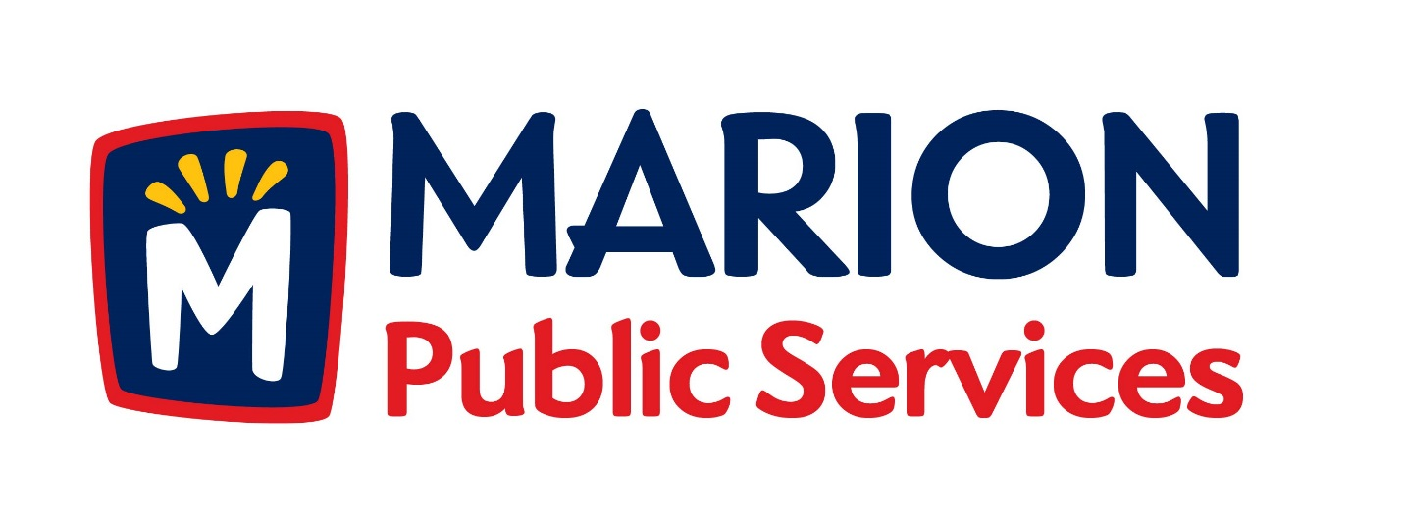

CITY OF MARION PUBLIC SERVICE BOARD
AGENDA
Noon
July 14th, 2015

- Approval of June Minutes.

- Motion to Approve House Pickup Request.

a. Knapp-1125 Elim Drive

- Discussion Regarding No Fault Sewer Backup Program

- Discussion Regarding Vacated Premise Policy.

- Discussion Regarding 501c Organization.

- Discussion Regarding Refuse Container Program

- Old Business/New Business.

- Adjournment.

