CITY OF MARION, IOWA
SUPPLEMENTARY SPECIFICATIONS TO SUDAS

These Supplementary Specifications amend or supplement the Statewide Urban Design and Standards (SUDAS) and other provisions of the Contract Documents as indicated below. All provisions which are not so amended or supplemented remain in full force and effect.

The terms used in these Supplementary Specifications will have the meanings indicated in SUDAS.

Division 1 – General Provisions and Covenants

Section 1010 – Definitions
1.03 Definitions and Terms
Add the following:
“SCHEDULE. A plan of procedure with reference to the sequence of and time allotted for each item or operation necessary for project, which is to be provided by the Contractor. The schedule shall clearly show start and end dates for major items and/or stages along with the critical path of the bid items and non-critical items. Upon submittal the schedule shall become the property of the City of Marion. The City has the right to utilize the schedule as the City sees fit, including but, not limited to posting it on social media, website, and/or newsletters. The schedule at a minimum shall include, but is not limited to: Project name, Prime Contractor and contact information, Critical Path, non-critical items, starting and ending dates of major milestones and/or bid items broken down into at least weekly scope, holidays.

Controlling Item of Work. The unique activity of a contract that will determine the duration of the construction period or if a working day is charged. The character of this work may change during the project. It is the work that could be in progress at any time that would have the greatest influence on the duration of the project. It could also have the biggest influence on safety and providing the least impact to the public (Section 1070 2.01 C) i.e. pouring back an intersection to provide access. It shall be as determined by the Engineer.”

Section 1040 – Scope of Work
1.09 CHANGED SITE CONDITIONS
B. Compensation
Add the following:
“3. Under no circumstances will payment for down time be made by the City of Marion as project field issues are being resolved. The City of Marion will take all necessary action to resolve issues in a timely manner.”

1.10 DISPUTED CLAIMS FOR EXTRA COMPENSATION
A. Basis of Claim for Extra Compensation
Add the following:
“6. Under no circumstances will payment for down time be made by the City of Marion as project field issues are being resolved. The City of Marion will take all necessary action to resolve issues in a timely manner.”

1.11 DELAYS CAUSED BY THE JURISDICTION
Add the following:
“Under no circumstances will payment for down time be made by the City of Marion as project field issues are being resolved. The City of Marion will take all necessary action to resolve issues in a timely manner.”

Section 1070 – Legal Relations and Responsibility to the Public
2.06 TRAFFIC CONTROL
B. Closing Street to Traffic
Delete Item 3 and replace with the following:
“3. The Contractor shall not remove, relocate, or reset any permanent Jurisdictional traffic control devices unless authorized to do so by the Engineer or contract documents. If a sign must be removed or relocated for any phase of construction, the Contractor shall notify the Engineer of the necessity of removal. The Contractor shall arrange for the removal, relocation, or resetting of temporary or permanent traffic control devices by the Contractor per the MUTCD to allow the work to proceed. This shall be included in the Traffic Control Item if there is one, if there is not it is incidental to other items in the contract.”

Section 1080 – Prosecution and Progress
1.03. WORK PROGRESS AND SCHEDULE
Add the following:
“D. The contractor shall submit a schedule two (2) weeks prior to the pre-construction meeting/conference or the meeting will be rescheduled until an acceptable schedule has been provided. The schedule is subject to the Engineers approval. If the contractor varies from the approved project schedule and/or sequence, as submitted to and approved by the Engineer; a revised schedule shall be submitted, by the contractor, for approval by the Engineer. If public notification has been made prior to the submittal of the revised and approved scheduled and the public needs to be re-notified, the contractor shall pay for the re-notification of the public including, but not included to mailings, website and social media posts.”

“E. As long as work exists on the project, the Contractor shall remain on the project. If issues exist with a portion of the project which is beyond the Contractor’s control (such as obstructions or utility issues), the City has the option to revise the Contract Phasing and direct the Contractor to work on other “unaffected” Phases or areas of the project as shown within the Contract Documents, at no additional cost to the City. The City may provide additional working days to the Contractor based upon relocation efforts and scheduling justification as determined by the Engineer.”

1.07 WORK ON SUNDAYS OR LEGAL HOLIDAYS
Add the following:
“C. The following are holidays observed by the City of Marion, in which no work will be allowed except as allowed below (City of Marion Holidays):
- New Year’s Day
- Good Friday
- Memorial Day (Including weekend)
- Independence Day
- Labor Day (Including weekend)
- Veterans Day
- Thanksgiving Day
- Day after Thanksgiving
- Christmas Eve Day
- Christmas Day
- New Year’s Eve Day
D. Allowing work on Saturdays and/or City of Marion Holidays is contingent on City of Marion Inspector and/or Engineer availability. A written request must be received by noon, to the Engineer, the Thursday prior to the Saturday or 48 hours prior to the Holiday in which work requiring inspection is to be performed. Work not requiring inspection may be performed with the permission of the City of Marion. Working day charges will apply to Holidays (including holiday weekends as noted above) in which work is allowed to commence. Overtime inspection charges will be charged at the discretion of the City of Marion as determined by the Engineer for days that the City allows work to be done. Cancelation of the scheduled work may result in the Contractor being charged for Inspectors time as determined by the Engineer with a minimum charge of 3 hours.”
1.12 LIQUIDATED DAMAGES
Add the following:
“D. Once work within a phase/project has begun, the Contractor shall work continuously within that phase/project until all work within that phase/project has been completed If work is not completed and the contractor removes their “normal” size crew and/or equipment from the phase/project without written authorization from the Engineer for more than five (5) consecutive working days, the Contractor will be considered to be “absent” from the project and will be charged a working day and immediately assessed the liquidated damage rate for each working day that the Contractor’s “normal” size crew and equipment are not working on the project. “Normal” size crew and equipment is as determined by the Engineer and the controlling operation. The Contractor will be notified within two (2) consecutive working days of being absent from the phase/project that this clause will go into effect after three (3) additional consecutive working days of being absent from the phase/project. Liquidated damages may be assessed at the time of monthly pay applications that cover any period during which the Contractor had unauthorized absences or work stoppages or on any subsequent pay application.
This paragraph 1.12(D) applies only to a situation in which the Contractor is absent from a phase/project for five (5) consecutive working days, and does not change, modify, or replace any other liquidated damage provisions found elsewhere in this contract.”

E. If vehicular access is restricted to a property identified on the plans as having ADA restrictions and the Contractor stops work as outlined in “D” above, the liquidated damages will accrue for each property AND for each working day that each property with ADA restrictions does not have vehicular access as determined by the Engineer.”

Section 1090 – Measurement and Payment

1.04 PAYMENT FOR CHANGE ORDERS
Add the following:
“B. 4. Time and Materials: By the Time and Material method. The Contractor shall submit a Rate Sheet detailing labor and equipment hourly costs prior to commencing the extra work. The Contractor and Engineer shall document the duration of the labor and equipment used and shall formalize this documentation by joint signature daily. The Contractor shall provide an invoice of the materials utilized for the extra work (if applicable) and said invoice price is allowed a 10% markup on the materials utilized for the extra work.”

1.05 PROGRESS PAYMENTS
Add the following:
“D. Stockpiled Materials: On contracts for which the contract sum is $10,000 or more, payments may be allowed based on value of processed or fabricated materials. Payment may be authorized for up to 100% of the invoice price for materials delivered and stored at the project site, or up to 90% of the invoice price for materials reserved for the project and stored elsewhere in a manner of storage that is satisfactory to the Engineer. Payment for stockpiled materials will not exceed 80% of the authorized amount of the associated bid item. Contractor is responsible for damages and material losses until the material is incorporated into the work and the work is accepted.”

“E. Schedule: The progress payment shall be withheld if the schedule provided by the Contractor is out of date by more than two (2) weeks and a revised schedule has not been provided and/or received and approved by the Engineer. An out of date schedule may be due to delays which could include, but are not limited to rain, utility work, or the Contractor or subcontractors being absent from the project.”

Division 2 – Earthwork

Section 2010 Clearing, Excavation, and Embankment
1.08 MEASUREMENT AND PAYMENT
F.2 Payment
Replace “existing embankments or following proof rolling operations.” with “embankments constructed as part of the project or once the grade has been approved following a successful proof rolling test.”

L. Compaction Testing
L. 1. Remove and Replace with:
“The Contractor shall be responsible for compaction testing and payment for testing unless otherwise specified in the Contract Documents.”

2.04 FOUNDATION MATERIALS
D. Subbase
Delete:
“1. Special Backfill
3. Modified Subbase”

3.01 CLEARING AND GRUBBING
D. Disposal
Add the following:
“Burning is not allowed within the City of Marion City Limits unless authorized by the City Engineer and City Fire Chief.”

3.04 EMBANKMENT CONSTRUCTION
C. Depositing Embankment Material
1. Add the following:
“No embankments shall be built on frozen earth.”

3.06 SUBGRADE PREPARATION
A. Uniform Composition
Add the following:
“A disk or plow shall be used for turning soil for drying. If conditions do not allow enough space for a disk or plow, the material shall be opened up for drying via other methods, proposed by the Contractor, with the approval of the Engineer.”

3.09 FIELD QUALITY CONTROL
B. Moisture Content and Density
1. Replace with the following:
“Ensure that moisture content fall within a range of optimum moisture of -1% to +4% of optimum moisture”

Division 3 – Trench and Trenchless

Section 3010 Trench Excavation and Backfill
2.01 MATERIALS EXCAVATED FROM A TRENCH
C. add the following:
“No additional compensation will be made for minor adjustments to elevations due to field conditions.”

3.05 PIPE BEDDING AND BACKFILL
E. Final Trench Backfill:
E.3a Replace: “Compact to at least 65% relative density within right of way” with “Compact to at least 98% of Standard Proctor Density within right of way.”
E.4c Replace the moisture range of optimum moisture with -1% to +4% of optimum moisture.

Division 4 – Sewers and Drains

Section 4010 – Sanitary Sewers
2.01 SANITARY SEWER (Gravity Mains)
Delete:
“A. Solid Wall Polyvinyl Chloride Pipe (PVC) 8 inch to 15 inch.
C. Corrugated Polyvinyl Chloride Pipe (PVC) 8 inch to 36 inch.
D. Closed Profile Polyvinyl Chloride Pipe (PVC) 21 inch to 36 inch.
I. Double Walled Polypropylene Pipe 12 inch to 30 inch.
J. Triple Walled Polypropylene Pipe 30 inch to 36 inch”

Add:
“A. Fiber Glass Reinforced, Polymer Mortar Pipe 18 inch to 126 inch.
- Comply with ASTM D3262.
- Joints shall be fiberglass sleeve couplings utilizing sealing gaskets per ASTM D 4161.
- Fittings shall be contact molded or manufactured from mitered sections of pipe joined by glass-fiber reinforced overlays.”

2.02 SANITARY SEWER FORCE MAINS
Add:
“F. Sanitary Sewer Gravity Main, Trenchless
a: Material shall be SDR-18 CERTA-LOC Pipe or approved equal”

Section 4020 Storm Sewers
1.08 MEASUREMENT AND PAYMENT
1. Trenched
c. Includes
Add the following: “For those storm sewers lines along the back of curb or under the Street the granular backfill shall be filled to the bottom of the granular subbase.”
3.06 Aprons
E. Replace “Install apron guard where specified in the contract documents.” with “Install apron guard on upstream apron for 15” pipe or larger. Do not install apron guard on downstream apron.”

Section 4030 Pipe Culverts
1.08 MEASUREMENT AND PAYMENT
1. Trenched
c. Includes
Add the following: “For those pipe culverts lines along the back of curb or under the Street the granular backfill shall be filled to the bottom of the granular subbase.”
3.02 Aprons
E. Replace “Install apron guard where specified.” with “Install apron guard on upstream apron for 15” pipe or larger. Do not install apron guard on downstream apron.”

Section 4040 – Subdrains and Footing Drain Collectors
2.06 SUBDRAIN OR FOOTING DRAIN CLEANOUTS
Add the following:
“C: Nyloplast Cleanout. Install per manufacturer specifications. Includes casting. Ductile iron frame (28.50) and solid grate (24.75) or approved equal. Inlet and outlet shall be 6”. Fill bottom of structure with concrete to flowline. Nyloplast shall be used unless otherwise specified in the contract documents.”
3.03 FOOTING DRAIN (OR SUBDRAIN) SERVICE STUBS
Add the following:
B.2.: Replace “For connection to existing footing drain, or subdrain the Tap Tee method (Fratco or other approved equivalent) should be used per manufacturer’s requirements.

Section 4060 – Cleaning, Inspection, and Testing of Sewers
3.02 VIDEO INSPECTION
A. General:
Add:
“5. Video Inspection by contractor shall only be required when specified in the contract documents.
6. The contractor shall coordinate with the Marion Public Works Department – Public Service Division for the televising of all the Sewers.
7. Any sewer that is not cleaned properly prior to request to televise sewer by the contractor shall be charged time and material to re-televise as determined by the Engineer.
8. The contractor shall clean the sewer prior to televising and shall perform any corrective action as required as a result of the televising at the contractor’s cost including re-televising after the corrective action is completed as determined by the Engineer.
9. The contractor may, at contractors’ cost, televise the sewer by an independent company and provide sewer tapes to the Public Works Department - Engineering Division for review for convivence of time. City of Marion Public Works Department – Public Service Division personnel must be present at the time of televising.”

Division 5 – Water Mains and Appurtenances

Section 5010 – Pipe and Fittings

1.08 MEASUREMENT AND PAYMENT
C. Fittings
2a. Fittings by Weight
Add:
“Marion Water Department will use the Tyler Union Water Works Catalog January 2019 for fitting weight for payment measurement regardless of the approved fitting brand’s actual weight. https://www.tylerunion.com/upl/downloads/library/tyler-union-waterworks-catalog-2.pdf

2.01 WATER MAIN
B. Ductile Iron Pipe (DIP):
1. Minimum Thickness Class:
Add:
- Ductile iron pipe shall be manufactured in accordance with the latest revision of ANSI/ AWWA C151/A21.51. The raw material for ductile iron shall have an average minimum recycled content consisting of 90% scrap iron and steel. Each pipe shall be subjected to a hydrostatic pressure test of at least 500 psi at the point of manufacture
- All ductile iron pipe shall be supplied by manufacturers in good standing with the Ductile Iron Pipe Research Association (DIPRA).
- All ductile iron pipe shall be manufactured domestically with manufacturing facilities residing in the U.S.
- Allowed US pipe manufacturers are American, McWane, US Pipe

2.02 BOLTS FOR WATER MAIN AND FITTINGS
A. Tee-Bolts and Hexagonal Nuts for Mechanical Joints:
Add:
“1. Corten Steel tee-bolts with fluorocarbon coating or department approved alternative high-strength, low-alloy steel manufactured according to AWWA C111.”

B. Other Bolts and Nuts:
Add:
“1. Stainless steel or Corten Steel with fluorocarbon coating”
Delete:
“2. Ductile iron”
3. Zinc, zinc chromate, or cadmium plated.

2.03 Fittings
D. Pipe Coupling:
Add:
“5. Fittings allowed for oversized pipe are:
- Romac Alpha XL restrained joint
- Krausz Hymax Grip

2.05 PIPELINE ACCESSORIES
B. Tracer System:
a. Solid Single Copper 12 gauge Conductor with min. of 0.045 mil insulation:
Add:
“4. Wire Connectors allowed:
- IDEAL 66R twist wire nut with silicone-based sealant
- Burndy KS15 copper split bolt
- All connectors will be wrapped with tapecoat T-tape” and inspected prior to burying

b. Bimetallic Copper Clad Steel Conductor”
Add:
“For Boring use only or as approved by Engineer.”
5. Tracer Wire Station:
Add:
“Department installs stainless steel strap on fire hydrants which is billed with hydrant purchased from department”

2.07 WATER SERVICE PIPE AND APPURTENANCES
B. Materials
2. DIP:
Add: All fire sprinkler risers and domestic riser pipes shall be DIP. Riser pipes shall be secured with ¾” stainless ready rod with stainless nuts and washers.

3. PVC Pipe
Delete:
“ASTM D 1785, Schedule 80 or ASTM D 2241. SDR 21. Provide solvent weld joints for all pipes”
Add:
“C900 with wall thickness of DR 18”

5. Polyethylene Pipe:
Add:
“Must receive special permission from department for use with multifamily units only after water service copper manifold installation. Manifold must be built from brass or stainless steel fittings. Pipe must be DR9 ASTM2737 with minimum of 250 psi rating, copper tubing size with tube stiffeners and compression fittings.”

“Copper Tube Size (CTS) pipe allowed on 1 ¼”, 1 ½”, and 2” water service lines”

“Private service lines shall have separate tracer wire starting at tap on water main with ground rod with bronze ground rod clamp with stainless steel bolts wrapped with Tapecoat T-Tape. (PRIVATE SERVICE LINE WIRE SHALL NOT CONNECT TO PUBLIC WATERMAIN TRACER WIRE) Tracer wire shall run the length of the service line where service line ends at water meter unless otherwise specified.

“Compression fittings allowed on 1 ¼”, 1 ½”, and 2” CTS water service lines”
- AY McDonald – Q-series compression or Cambridge multiple Ranger multiple OD coupling
- Mueller – 110 compression connection for CTS OD tubing

C. Corporations, Stops, and Stop Boxes:
Add:
“Corporation Stop Allowed
- Mueller H-15000
- AY McDonald 74701

Curb Stop Allowed
- Mueller H-25204N
- AY McDonald 76100

Curb Box Allowed
- Mueller H-10334
- AY McDonald 5607
All curb boxes shall have a stainless steel valve operator extension rod, ½-inch in diameter x 42 inches long”
“ Stop box lids shall have center pentagon access with bolt on bottom of lid to attach locate wire to for plastic water service lines”

2.09 CASING PIPE
Add:
“A. Polyethylene film: 8 mil thickness; black pigmentation; wrap DI pipe as recommended by manufacturer; ANSI A21.5; Clow Corporation F-192, or equal; use for corrosion protection on all iron pipe, fittings, and valves.
- Use flat tube with and polyethylene overlap recommended by manufacturer for various pipe diameters.
- Use 2”x8 mil polyethylene adhesive tape with paper backing.

B. Steel casing pipe (S): smooth wall welded steel pipe, ASTM A139; minimum wall thickness: 0.3125”; use for casing pipe where shown on plans.
1. Coat outside of pipe with asphalt liquid, Iowa Paint Mfg. Co. No 31, or equal.
2. Welded joints in conformance with Code of Arc and Gas Welding on Building Construction by AWS.
3. Bevel or space ends of pipe to ensure penetration of weld for full thickness of pipe.

3.01 PIPE INSTALLATION
Delete:
A.8 “and when specified in the contract documents,”
Add:
“12. Minimum pipe bury depth is 5.5’”
“13. When water main run ends with a valve, restrain the last two full lengths of pipe with a flange/mega lug assembly with stainless threaded rod and nuts and wrapped in plastic. Item is incidental to main installation. See Exhibit D.”

3.05 TRACER SYSTEM INSTALLATION
F.
Delete: “wire station”
Add: “stainless steel locator strap installed by Marion Water Department”
G. Upon completion of project, locating wires shall be tested to insure proper functionality.
3.09 WATER SERVICE STUB
Add:
“D. Marion Water Department to install all taps up to 2 inches in diameter. Contact department for material costs and inspection fees if applicable.
E. Water main to be in service and all tests passed prior to ordering taps 48 hours in advance.
F. Lot pins to be placed prior to making taps.
G. Taps larger than 2” in diameter shall be made the contractor with approved materials per Marion specifications”
H. Install blue painted steel tee fence posts by all water service curb boxes
Section 5020 – Valves, Fire Hydrants, and Appurtenances

1.07 SPECIAL REQUIREMENTS
Add:
“Contractor to obtain fire hydrant assembly (includes 6” valve and stainless steel locator strap) from Marion Water Department. Contractor to purchase valve box, lid and anchor tee and pipe separately.”
“Contractor must check tightness of all pressure-containing bolts on the fire hydrant and attached valve prior to installation as bolts may have loosed during shipment. Contractor to follow ANSI/AWWA C600 for proper installation procedures.”
1.08 MEASUREMENT AND PAYMENT
C. Fire Hydrant Assembly
3. Includes:
Add: “stainless steel locator strap and Anchor Tee and pipe shall be paid for as part of the Fire Hydrant Assembly and paid for separately”

E. Valve Box Adjustment, Minor:
Add:
“Valve box adjustment extensions will be incidental.”

2.01 VALVES
B. Gate Valves
1. Standards:
Delete: “AWWA C515”
Add:
“4. Operating nut to be attached to valve stem by bolt or nut type connection
5. Valve stem shall be brass and removable without removing valve bonnet
6. Finish: in accordance with ANSI/AWWA C509. Fusion bonded epoxy per AWWA C550, interior and exterior
7. Valves allowed:
a. Clow
b. Kennedy
c. Mueller
d. U.S. Pipe”
8. Install blue painted steel tee fence posts by all valve boxes

D. Tapping Valve Assemblies
1. Tapping Valve:
Delete: “AWWA C515”
Add:
“8. Tapping valve shall have alignment lip to mate with tapping saddle
9. Tapping sleeve shall be made of:
a. Minimum 18-8 stainless steel
b. Gasket- nitrile NSF-61 approved
c. Flange shall be 18-8 stainless steel type (304) with ANSI class 150# drilling pattern
1. Per AWWA C207 class “D”
d. Flange shall be machined with a recess MSS SP-60 to accept tapping valves
e. Nuts, bolts and washers shall be 304 stainless steel
f. Nuts and bolts shall be coated to prevent galling
g. Test port shall be ¾” welded stainless steel with IPS stainless steel pipe plug
h. Tapping sleeves shall follow ASTM A380-06 and ASTM A967-05 for cleaning, de- scaling and passivation treatment
i. Acceptable tapping saddles are Mueller H-304SS, Smith-Blair 665, Triple Tap series TS
10. Tapping sleeve shall be tested prior to tapping, in accordance with department rules.
11. Sleeve and valve shall be supported by 4”x8”x16” solid block

2.02 FIRE HYDRANT ASSEMBLY
B. Manufactures:
Add:
“Contractor shall obtain fire hydrant from Water Department which comes with 6 inch valve and stainless steel locator strap.
Approved manufacturer – Mueller Super Centurion 200
See detail - Fire Hydrant Exhibit A & B – Type II – Marion
If needed, Marion Water Department will raise fire hydrant and bill contractor. Contractor shall adjust valve boxes.”

2.03 APPURTENANCES
A. Flushing Device (Blowoff):
Add:
“See Exhibit C – Blow off Detail”
B. Valve Box:
2. Manufacturer:
Add:
“Approved manufactures are:
        - East Jordan Iron Works
        - Sigma HD
        - Tyler valve box extensions only. Tyler Domestic 26T 6855 slip top sections and Tyler Domestic 5 1/4 drop lid allowed.

3.03 FIRE HYDRANT
Delete:
- “Figure 5020.201”
F. Entirely
Add:
- “Exhibit A & B”
F. Orientation of Fire Hydrant nozzles done by Water Department

Exhibit A

Exhibit B

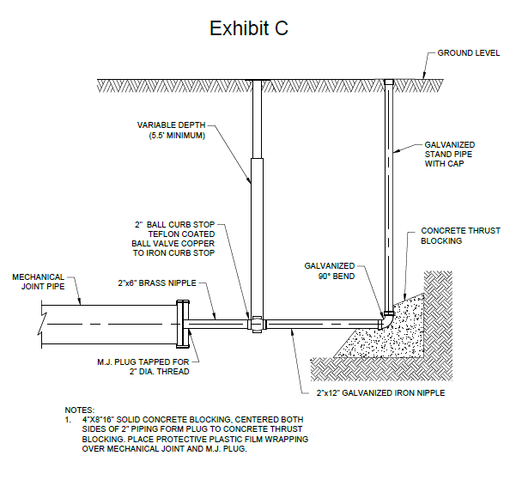

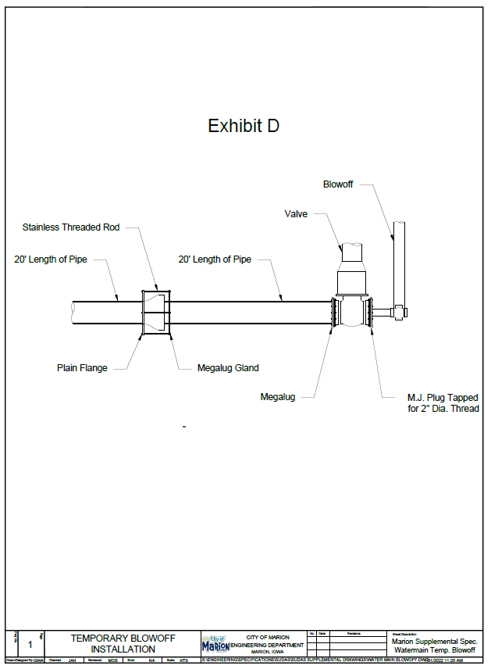

Division 6 – Structures for Sanitary and Storm Sewers

Section 6010 – Structures for Sanitary and Storm Structures
1.08 MEASUREMENT AND PAYMENT
D. Casting Extension Rings; change to the following:
“1. Measurement: Each casting extension ring will NOT be counted.
2. Payment: Payment will be incidental to each structure and shall be included in cost of said structure. No additional payment will be made.”

2.03 CAST-IN-PLACE
B. Reinforcement
Add:
“All reinforcement steel shall be epoxy coated when structures are cast in place, unless otherwise indicated on the plans.”

2.05 PRECAST RISER JOINTS
B. Joint Sealant:
1. Sanitary Sewer
Remove: “b. Bitumiouns Jointing Material and
c. Butyle Sealant Wrap”
2.08 PIPE CONNECTIONS
Add: “E. Connection to sanitary sewer manhole shall be A-Lock or approved equal”

2.10 CASTINGS (Ring, Cover, Grate, and Extensions)
DELETE:
“C. Composite”

E. Manholes, add the following:
“When bolted covers are specified, bolted covers shall use a removable/replaceable nut system. East Jordan Iron Works 1045Z or approved equal.”

2.13 STEPS
Modify:
“A. Provide steps in all circular, precast manholes unless otherwise specified in the contract documents.”

Detail SW-301
Remove: “Flexible Pipe Connection (typ.)”
Add: “A-Lock or approved equal by Engineer (typ.)”

Detail SW-512
Remove: “SW-604 Type 3, 4, or 5 Casting”
Add: “SW-604 Type 3 Casting”

Division 7 – Streets and Related Work

Section 7010 – Portland Cement Concrete Pavement
1.07 SPECIAL REQUIREMENTS
Add:
“When placing PCC, the Contractor shall protect adjacent fixtures from concrete splatter or direct contact with concrete. Fixtures shall include but are not limited to light poles, light pole bases, controller cabinets, hand holes, buildings, manhole lids, water valve lids and fire hydrants.”

“Pavement less than 15 years old shall be removed to full panel joint lines or as designated by the Engineer.”

1.08 MEASUREMENT AND PAYMENT
B. Air Content Deficiency
Remove part 2 (two) Payment, and replace with:
“All concrete which has an air content deficiency according to Section 7010, 3.08 shall be removed and replaced at the cost of the contractor as determined by the Engineer.”

C. Pavement Smoothness Deficiency
Remove Section

D. Pavement Thickness Deficiency
Add:
“The concrete shall be removed and replaced at the cost of the contractor at the Engineers discretion if it does not meet pavement thickness.”

I. PCC Pavement Samples and Testing
Remove 1, 2, & 3 and replace with:
“1. Maturity testing is incidental to pavement items and no separate payment will be made for these tests. Pavement smoothness shall be required on all non-locally classified streets or if specified by contract documents and shall be incidental to pavement items and no separate payment will be made for testing or corrective actions required. Pavement thickness cores will be required if yields do not check per section D and is incidental to the pavement items. Certified plant inspection, if specified in the construction documents, is also incidental to the pavement items.”

2.01 MATERIALS
H. Bars
Remove:
“or Iowa DOT Section 4156 for glass fiber reinforced polymer dowel bars.”
Add:
“Glass fiber reinforced polymer dowel bars are not allowed”
3.02 PAVEMENT CONSTRUCTION
E. Bar and Reinforcement Placement
Add:
“5. Utility Crossing Reinforcement: Reinforcement shall be required at all storm sewer crossings and all sanitary sewer crossings that have less than 5 feet of cover between the top of the pipe and the bottom of the proposed pavement or as specified on the contract documents. Reinforcement shall be #5 epoxy coated bars, 15 foot long at 18” on center. Tied chairs supports and anchors shall be used. Bars shall be set and supported before paving. Overlaps will not be measured for payment. If there is no contract bid item this shall be incidental to other items.”

J. Construction of Joints
Add to F:
“The City of Marion has a Noise Ordinance from 10:00 PM to 7:00 AM except for saw cutting of fresh concrete. The contractor must inform the Engineer if the contractor will be sawing during the Noise Ordinance so that the City of Marion Police Department can be notified.”

3.04 PAVEMENT PROTECTION
A. Weather Conditions
Add:
“B. When cold weather protection is required it shall be paid per Iowa Department of Transportation Standard Specifications for Highway and Bridge Construction Section 2301.05 Part K. Heating Water for Concrete Mix shall be the customary amount charged for heating, and separately identified on the invoice, with a maximum of $5.00 per cubic yard if ordered by the Engineer and under the same conditions of 2301.05 Part K. If Contractor elects to do work without Engineer direction no payment will be made for cold weather protection”

B. Night Conditions
Add:
“Night work, if approved by the Engineer, shall meet the following requirements: The Contractor shall meet the requirements of Iowa DOT Specification 2550, including but not limited to submitting a Lighting Plan, Light Meter, and providing the minimum lighting intensity of 5 foot candles over the entire work area. Work performed without meeting these requirements will be rejected and the cost borne by the Contractor. The additional costs of night work shall be the responsibility of the Contractor.

C. Protection From Traffic
Add:
“4. Minimum Cure Time: Regardless of maturity method TTF value achieved, no PCC pavement shall have loadings applied to it, including but not limited to a paving machine, other than saw and sealing trucks until a minimum of 72 hours after pavement of a continuous pour was placed.”

3.07 Quality Control
A. Testing
Add:
“Certified Plant Inspection will only be required if specified in contract documents. Approved Sources, Field Tests and Maturity tests shall be completed.”

D. Pavement Thickness
Add:
“5. Yield will be checked per field measurements and cores will only be required if yield is not met or deficiencies are determined and/or suspected by the Engineer.”

Detail PV-103:
Modify:
“Thickness of boxout shall be 10 inches minimum”
“Joint between boxout and mainline shall be KT-2 or BT-3”
“Secure tie reinforcement bars to pavement dowels”
“#5 epoxy coated bar 5’ long in diamond and square pattern, to fit boxout size. For Circular Boxouts use #5 epoxy coated hoop bars (variable length). All bars to be placed at mid slab”
“Boxouts shall be 6’ by 6’ or a 6’ DIA Circle.”
“See detail below for reference.”

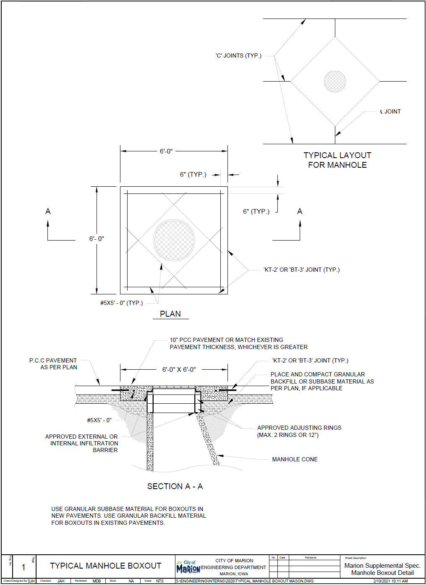

Section 7020 – Asphalt Pavement
1.08 MEASUREMENT AND PAYMENT
Delete:
“G. Asphalt Pavement Thickness Deficiency
H. Asphalt Pavement Smoothness Deficiency”

I. Asphalt Pavement Samples and Testing:
Remove and replace 2.:
“Pavement samples and testing shall be incidental to Asphalt items. No additional payment shall be made.”

Section 7030 – Sidewalks, Shared Use Paths, and Driveways
1.08 MEASUREMENT AND PAYMENT
Delete:
“F. Brick/Paver Sidewalk with Pavement Base”
2.07. DETECTABLE WARNINGS
Add:
“Sidewalks and shared use paths 6’ or wider shall use detectable warnings constructed of black 10ga galvanized steel.”

Figure 7030.207:
Modify:

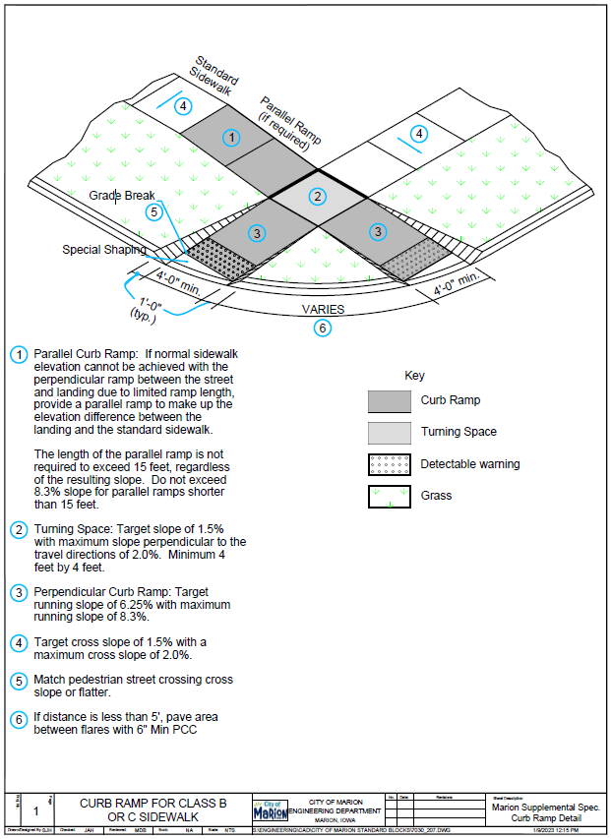

3.04 PCC SIDEWALK, SHARED USE PATHS, AND DRIVEWAYS

F. Jointing
2. Transverse Contraction Joints
a. Shared Use Paths:
Add:
“3) Provide a ½” expansion joint every 75’ or nearest joint.”

b. Sidewalks and Driveways:
Add:
“4) Provide a ½” expansion joint every 75’ and or at nearest joint and on all four edges between the sidewalk through the driveway and the driveway.”

4. Isolation Joints
Add:
“e. Isolation joints shall be sealed, including joints that butt against the back of curb.”

G.: Add:
“G. Pedestrian Facility Compliance and Acceptance:
Contractor is responsible for constructing all new pedestrian facilities in accordance with the plans, specifications and applicable standards. Pedestrian facilities include, but are not limited to, sidewalks, shared use paths, pedestrian ramps and sidewalks.”

Remove:
“Section 3.06 BRICK/PAVER SIDEWALKS WITH A PAVEMENT BASE”

Figure 7030.101
Driveway and curb opening widths for new pavement shall conform to the requirements listed in the City’s General Supplemental to SUDAS Design Manual. Unless approved by the Engineer existing curbs shall be ground down for the opening, driveways shall require 1” of expansion at the back of the curb, and the sidewalk thru the driveway shall be 5’ wide minimum.

Figure 7030.102
Application of this detail shall not be used in the City of Marion. Integral driveways are not allowed without approval of the Engineer.

Figure 7030.201
Add:
4. Removal and replacement of sidewalk on a property requires installation of at least one 5’x5’ panel if over 50% of the sidewalk is being replacement and if there is not an existing 5’x5’ panel within 200’ in each direction.

Figure 7030.204
The ½ inch expansion material is to be placed around the entire landing area except where it butts up next to the perpendicular curb ramp.

Figure 7030.205
The ½ inch expansion material is to be placed around the entire landing area except where it butts up next to the perpendicular curb ramp.

Figure 7030.207
The ½ inch expansion material is to be placed around the entire landing area except where it butts up next to the perpendicular curb ramp.

Section 7040 – Pavement Rehabilitation
1.07 SPECIAL REQUIREMENTS
Add:
“When placing PCC, the Contractor shall protect adjacent fixtures from concrete splatter or direct contact with concrete. Fixtures shall include but are not limited to light poles, light pole bases, controller cabinets, hand holes, buildings, manhole lids, water valve lids and fire hydrants.”

“Pavement less than 15 years old shall be removed to full panel joint lines or as designated by the Engineer.”

3.11 CORE HOLE CUTTING AND REPLACEMENT
C. Pavement Core Replacement
2. Add:
“Concrete material to be approved in Iowa DOT MAPLE under Concrete Repair, Rapids Set Patch Material”.
Add:
“4. PCC Pavement less than 15 years old shall be removed to full panel joint lines or as designated by the Engineer. Replacement shall meet the requirements of Full Depth Patches.”

Division 8 – Traffic Control

Section 8010 – Traffic Signals
1.08 POLES, HEADS, AND SIGNS
C. Traffic Signal Poles and Mast Arms:
Remove:
1.h “For mast arms over 50 feet length, two-piece mast arms with a slip-fit and bolt connection are allowed.”

Division 9 – Site Work and Landscaping

Section 9010 – Seeding
1.08 MEASUREMENT AND PAYMENT
E. Warranty:
Remove and Replace:
“2. Payment: Payment shall be incidental to seeding item(s) and shall be included on all projects.”

Section 9010 – Seeding
3.10 ACCEPTANCE AND WARRANTY
B. Warranty:
Remove: “1. Required only when established as a bid item by the Engineer.”
And Replace: “1. Required on all projects and incidental to other items.”

Section 9030 – Plant Material and Planting
2.06 TREE PROTECTION
Replace:
“Install a 3-4” diameter tube (corrugated or vinyl plastic), specifically manufactured for tree trunk protection, having qualities to resist insect infestation and to allow free air flow to trunk tissues, or similar material approved by the Engineer.”

3.06 PLANTING
Replace:
4b. “After plant placement, cut and remove all of the wire, burlap, and twine from root ball”
3.07 WATERING
Add:
B. “Water trees a minimum of 10 gallons per inch of tree diameter per week when less than 1 inch of precipitation is received in the immediate location. Double the watering frequency during extreme heat and dry summer periods.”
Section 9040 – Erosion and Sediment Control
1.08 MEASUREMENT AND PAYMENT
A. Stormwater Pollution Prevention Plan (SWPPP)
2. Management
Add:
“Includes scheduling and performing weekly inspections jointly with the City of Marion Inspector or designated representative.”

3.02 SWPPP MANAGEMENT
Add:
D. “Weekly inspections shall be performed by a representative of the Prime Contractor, or their designated subcontractor (when applicable), and shall be performed jointly with the City of Marion Inspector. Weekly inspections shall not occur on weekends or recognized holidays. Inspection reports shall be signed by both the Prime Contractor’s representative, or their designated subcontractor (when applicable), and the City of Marion Inspector present at the time of inspection.
Failure to perform weekly inspections jointly with the City of Marion Inspector shall result in an issuance of a non-compliance and a price adjustment shall be made in accordance with Section 1040.1.04.C.
Individuals performing weekly inspections shall be current on erosion and sediment control training. Completion of the Iowa DOT Erosion & Sediment Control Basics (ESC Basics) training, or and approved equal, will satisfy the training requirement.”

Division 10 – Demolition

Section 10,010 – Demolition of Building Structures
3.02 UTILITY DISCONNECTIONS
A. Sanitary Sewer
Remove and Replace:
“Sanitary Sewer: Prior to demolition of any building or structures, the branch sanitary sewer or sewers serving the building shall be cut off at the Right-of-Way, or as directed by the Engineer, and shall be tightly and permanently sealed with a plug of mortar. The plugs shall be subject to the approval of the Engineer prior to backfilling. The contractor shall keep a temporary plug, either friction-type or a cap in the sewer line, to prevent storm water and debris from washing into the line prior to the construction of the final plug. Disconnection and plugging of sanitary services shall be per Section 4010, 3.08. Notify Engineer for inspection prior to placing backfill material.”

B. Water Service
Remove and Replace:
“Water Service: Water Service shall be disconnected by the Contractor at the main prior to the demolition. The location of water mains, where known, will be provided by the local jurisdiction. The Contractor may be required to schedule excavations in certain streets in accordance with the requirements of the local jurisdictions. Methods of Work on mains and services will be subject to prior approval and inspection by the Engineer. The disconnection shall be subject to approval by the Engineer prior to backfilling. Those water services controlled by a corporation cock valve on the main shall be disconnected at the main by closing the cock valve and disconnecting the service lines. A cap or corporation nut shall be put on the corporation cock valve. Those water services controlled by gate valves shall be disconnected as near as practical to the main by closing the valve, replacing the stem package, disconnecting the first joint away from the valve and installing a cast iron plug designed to fit the type of joint found. A concrete thrust block shall be poured against the plug in such a manner that it will bear against undisturbed earth. Care shall be taken in forming this thrust block so that the plug could be removed if desired for a future connection.”

C. Storm Sewer
Remove and replace:
“Storm Sewer: Prior to demolition of any building or structure, roof drains or area drains connected to the storm sewer system shall be cut off at the back of curb and that portion of the branch sewer shall be permanently sealed with a plug of mortar no less than one foot thick. The plug shall be subject to approval by the Engineer prior to backfilling.”

Division 11 – Miscellaneous
Section 11,010 – Construction Survey
1.07 SPECIAL REQUIREMENTS
Add:
“D. The Jurisdiction shall not be required to provide electronic AutoCAD files or electric files including but not limited to surfaces. The contractor shall perform the work via the survey stakes provided by the Jurisdiction. At the discretion of the Engineer a limited electronic file may be provided given the contractor signs the Electronic Media Release.”
3.04 – DISTURBED MONUMENTS
Remove and Replace with:
“Replace land corners, property corners, permanent reference markers, and benchmarks specified in the contracts documents, or if disturbed during construction by a Licensed Surveyor in the State of Iowa at the cost of the contractor and is incidental to other bid items.”

End of Section
Adopted 2.20.25
City of Marion Resolution 32264

