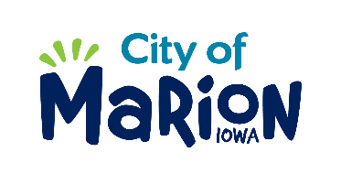 | PUBLIC SERVICE BOARD AGENDA  Tuesday, February 16th, 2021 – 12:00 p.m.  Marion City Hall

- Call to Order

- Roll Call

- Motion approving the minutes from the December 2020 Public Service Board Meeting.

- Motion to approve request for House Collection Services.

  - Kelly-4060 Monarch Avenue
  - Olson-2570 17th Avenue
  - Nielson-880 S12th Street

- Motion to approve the 2021 Holiday Refuse Collection Schedule

- Update on Derecho Debris Removal activities and facility repairs.

- Update on Fiscal Year 2022 Budget.
- Other Business

- Adjourn

