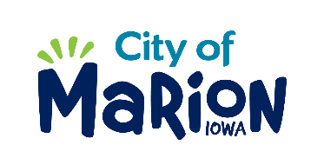 | PUBLIC SERVICE BOARD AGENDA  Tuesday, November 10th , 2020 – 11:00 a.m.  Marion City Hall

- Call to Order

- Roll Call

- Motion approving the minutes from the June 2020 Public Service Board Meeting.

- Motion to approve request for House Collection Services.

  - Wyatt-485 Valleyview
  - Smith-1700 10th Avenue
  - Anderson-3420 Sunburst Avenue
  - Soenksen-3175 Sunburst Avenue
  - Martin-3119 35th Avenue
  - Meyers-3445 Willowridge Road Unit B
  - Peck-1195 Elim Drive #C
  - Nuehring-3066 35th Avenue

- Discussion regarding Five Year Financial Plan and FY22 Budget (Zach Wolfe-Budget Manager).

- Discussion regarding Derecho Response and Storm Cleanup Operations.

- Discussion regarding Public Service Facilities.

- Other Business

- Adjourn

