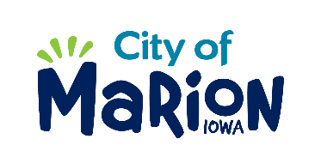 | PUBLIC SERVICE BOARD AGENDA  Tuesday, March 10th, 2020 – 12:00 p.m.  MARION PUBLIC SERVICES  195 35TH STREET, Marion, IA 52302

- Call to Order

- Roll Call

- Motion approving the minutes from the February 2020 Public Service Board Meeting.

- Motion to approve request for supplemental solid waste collection services.

  - Betzer-600 West 8th Avenue

- Review of Winter Maintenance Operations

- Update regarding Eco Industrial Park.

- Other Business

- Adjourn

