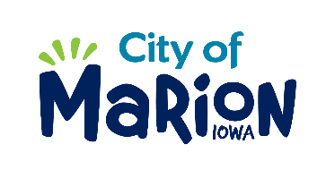 | PUBLIC SERVICE BOARD AGENDA  TUESDAY, DECEMBER 6TH, 2019 – 12:00 p.m.  MARION PUBLIC SERVICES  195 35TH STREET, Marion, IA 52302

- Call to Order

- Roll Call

- Motion approving the minutes from the November 2019 Public Service Board Meeting.

- Motion to approve applications for house collection services.

  - Hall-1275 Parkview Drive
  - Leonard-3850 White Tail Drive #A
  - High-1785 Hunters Creek Parkway
  - Corpstein-1475 James Drive

- Discussion regarding the 2019-2020 Public Service Budget.

- Update regarding Eco Industrial Park.

- Other Business

- Adjourn

