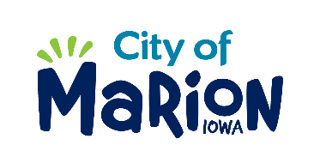 | PUBLIC SERVICE BOARD AGENDA  TUESDAY, OCTOBER 8th, 2019 – 12:00 p.m.  MARION PUBLIC SERVICES  195 35TH STREET, Marion, IA 52302

- Call to Order

- Roll Call

- Motion approving the minutes from the October 2019 Public Service Board Meeting.

- Motion to approve applications for house collection services.

  - Jayne 3350 24th Avenue
  - Bouslog 3130 Willowridge Road Unit A
  - Tonkin 1920 8th Avenue
  - Edaburn 3210 35th Avenue

- Motion to approve the 2019-2020 Snow and Ice Control Program.

- Discussion regarding the 2019-2020 Public Service Budget.

- Update regarding Eco Industrial Park.

- Other Business

- Adjourn

