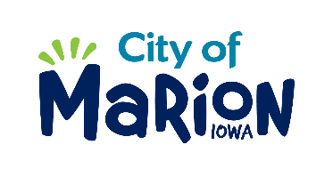 | PUBLIC SERVICE BOARD AGENDA  TUESDAY, OCTOBER 8th, 2019 – 12:00 p.m.  MARION PUBLIC SERVICES  195 35TH STREET, Marion, IA 52302

- Call to Order

- Roll Call

- Motion approving the minutes from the September 2019 Public Service Board Meeting.

- Motion to consider waiver of sanitary sewer fees associated with water consumption for irrigation (Joshi 1190 Adare Pass).

- Discussion regarding sanitary sewer connection fees.

- Discussion regarding recycling and solid waste programming.

- Public Service Board appointments.

- Update regarding Eco Industrial Park (Optional site visit for Board Members-weather permitting).

- Other Business

- Adjourn

