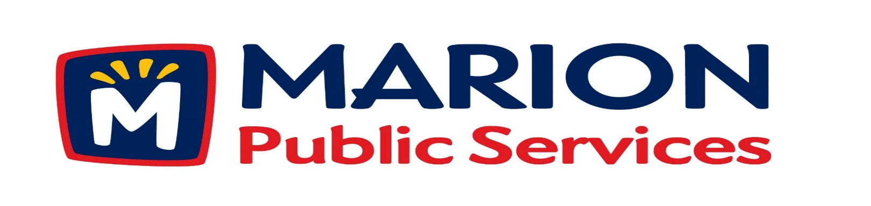
Minutes
Public Services Board
City of Marion
Tuesday, August 13th, 2019

Present: Tom Padley, Craig Adamson, Joe Spinks and Mark Morgan

Absent: Colleen Prokop

Staff: Ryan Miller and Diane Toy

- Motion to Approve the July 2019 Minutes.

- Discussion regarding Public Service Department Structure and Deputy Director Positions.

- Update on the Public Service Maintenance Facility.

- Old Business/New Business.

- Adjournment.

Minutes
Public Services Board
City of Marion
Tuesday, August 13th, 2019
Continued

ITEM 1 Approval of July 2019 Minutes.
Craig Adamson called to order the regular meeting of the Public Service Board on Tuesday, August 13th, 2019 at 12:05PM. A motion to approve the July 2019 minutes was made by, Mark Morgan seconded by Joe Spinks, approved by all, Motion carried.

ITEM 2 Discussion regarding Public Services Department Structure and Deputy Director Positions.
Ryan talked to the PS Board about the new structure for the Public Service Department and how having 2 Deputy Directors would be beneficial for the department. The 2 positions would have their own core responsibilities but would work together. Deputy Director Administration’s core responsibilities would be safety, policies (review & development) which would include a department handbook (will work with MRA), administrative training, employee relations, admin/tech support and evaluations and professional development. Deputy Director Operation’s core responsibilities would be work schedule development, infrastructure review and programing, operations review, employee relations and tech support for maintenance operations and hands on with daily operations. We will be working on the details on the Leadership training, communications and professional training (soft skills).
Minutes
Public Services Board
City of Marion
Tuesday, August 13th, 2019
Continued

ITEM 2 Discussion regarding Public Services Department Structure and Deputy Director Positions continued.
Ryan will transition his role into working on Strategic priorities, budget, building projects and refine work schedules after they are submitted and special projects. The department organization chart will change with the placement of the Deputy Directors and the addition of Specialist (which are leader positions). Craig and Mark would like to have the story of Public Services told of how we have grown and changed as the city has grown and show the old organization charts to the new one. The PS Board would like to see graphics and talk at a later date and would like to see more information on the website, what we doing and where we are going. They will readdress this topic after the Deputy Directors have been hired.

ITEM 3 Updates on the Public Services Maintenance Facility.
Ryan updated the PS Board on the progress of the Eco Industrial Facility. The civil engineering is complete. Rathje still have to dig the pond and working on dirt wok on property across the street on 44th Street. Geothermal work has started and is moving along and on schedule. The footings went out for bid and have been returned and will soon with an end date of October 24th, 2019. The bids for the metal part of the building have gone out and been returned, as have the concrete precast bids. Ryan and staff are starting to look into the equipment and working on the utilities connection. The PS Board would like to schedule a tour out the new building site and do it as a group, so Ryan will only have to do it once.

Minutes
Public Services Board
City of Marion
Tuesday, August 13th, 2019
Continued

ITEM 4 Old Business / New Business

None

ITEM 5 Adjournment.
The meeting was adjourned at 12:58PM. A motion was made by Craig Adamson, seconded by Tom Padley, approved by all members, Motion carried.

Next PS Board meeting is scheduled for Tuesday, September 10th, 2019 at noon.

Respectfully submitted by:

____________________
Ryan Miller
Public Service Director

RM/dpt

