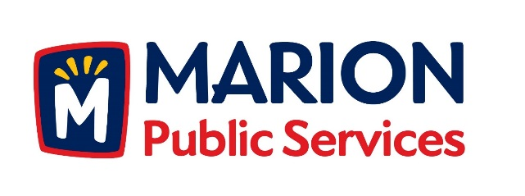

CITY OF MARION PUBLIC SERVICE BOARD
AGENDA
Noon
July 9th, 2019

- Motion to approve the June 2019 Minutes.

- Motion to approve fees for bulk item collections.

- Discussion Regarding 28E Roadway Maintenance Agreement with Linn County.

- Updates on the Public Service Maintenance Facility.

- Old Business/New Business.

- Adjournment.

