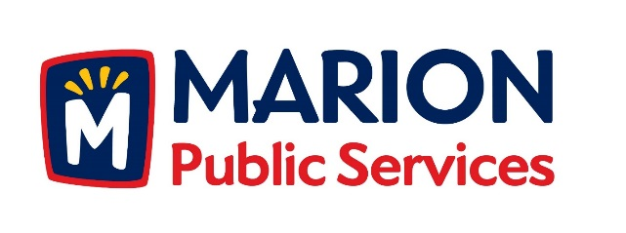

CITY OF MARION PUBLIC SERVICE BOARD
AGENDA
Noon
June 11th, 2019

- Motion to approve the May 2019 Minutes.

- Motion to approve the Equipment Rate Schedules.

- Update on Wastewater Treatment Agreement

- Updates on the Public Service Maintenance Facility.

- Old Business/New Business.

- Adjournment.

