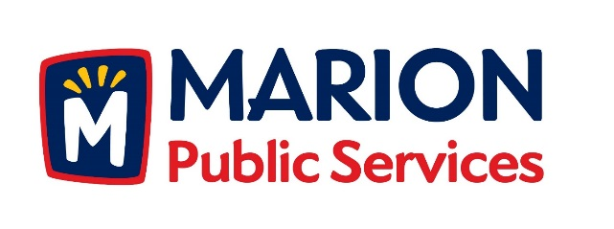

CITY OF MARION PUBLIC SERVICE BOARD
AGENDA
Noon
May 14th, 2019

- Motion to approve the April 2019 Minutes.

- Motion to approve the 2019 Public Services Work Program.

- Discussion regarding Solid Waste and Sanitary Sewer Fee Schedules.

- Update on Phase I of the Eco Industrial Park.

- Old Business/New Business.

- Adjournment.

