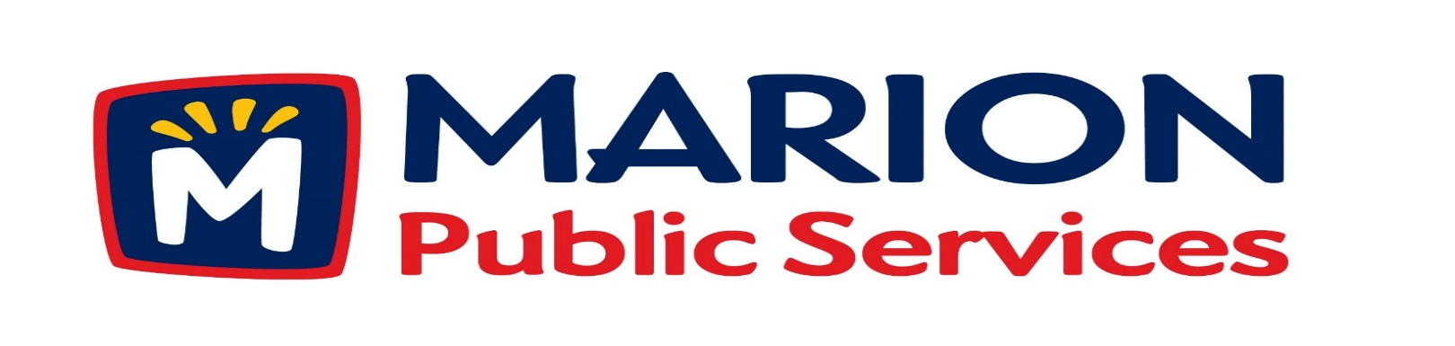
Minutes
Public Services Board
City of Marion
Tuesday, April 9th, 2019

Present: Tom Padley, Colleen Prokop, Craig Adamson, and Joe Spinks

Absent: Mark Morgan

Guest: Zach Wolfe – City of Marion Administrative Services

Staff: Ryan Miller and Diane Toy

- Motion to Approve the March 2019 Minutes.

- Motion to approve job description for Deputy Director – Public Service Department.

- Discussion regarding Solid Waste and Sanitary Fee Schedules.

- Discussion regarding Solid Waste Management.

- Update on Phase I of Eco Industrial Park.

- Old Business/New Business.

- Adjournment.

Minutes
Public Services Board
City of Marion
Tuesday, April 9th, 2019
Continued

ITEM 1 Approval of March 2019 Minutes.
Craig Adamson called to order the regular meeting of the Public Service Board on Tuesday, April 9th, 2019 at 12:10PM. A motion to approve the March 2019 minutes was made by, Colleen Prokop seconded by Tom Padley, approved by all, Motion carried.

ITEM 2 Motion to approve job description for Deputy Director – Public Services Department.
Ryan told the PS Board that the position for the Public Service Deputy Director has been on the books since FY19 and has been approved by the City Council. Ryan talked about possibly splitting the job into 2 positions – 1 on the Operational side and 1 on the Administration side. Ryan discussed the qualifications for the position with the PS Board and all agreed it is a higher level positions. Ryan is using an outside firm to help with the search for qualified applicants. Joe asked about adding the Deputy Public Service Director and if any other departments in the city has one? Ryan said Parks and the Library has one already. Our goal is to move towards a data driven department. Any PS Board members who would like to be a part of the interview just let Diane know. Ryan also updated the PS Board on the operator positions 1 would be additional and 2 are to back fill open positions. As long as the City and The City Council wants to maintain the current level of service we need to add to our current level of staff. Craig asked how the winter will affect our work for the season. Ryan said we had a lot of blow ups due to severe weather this winter and we are trying to fix those first and will move onto the work program. Craig would like us to stay ahead of the workload / operators before the jobs gets bigger then the number of operators. A motion was made by Tom Padley to approve the job description for the Deputy Public Service Director, seconded by Joe Spinks, approved by all members, Motion carried.

Minutes
Public Services Board
City of Marion
Tuesday, April 9th, 2019
Continued

ITEM 3 Discussion regarding Solid Waste and Sanitary Sewer Fees Schedule.
Ryan talked about how the flow meters installed by the City of Marion are tracking the flow into Cedar Rapids. Cedar Rapids feels that the flow meters are not working correctly and we still have not come to an agreement yet. Ryan would like to see a service fee per water meter and add fees for multiple users on one meter. The fees would include a service fee (per water meter), a replacement fee and a user fee. Ryan thinks he may have answer by the May PS Board meeting about the rate for O & M fees paid to Cedar Rapids. We are having a big influx of multi-unit senior living centers. Solid Waste fees will have to be increased as will Special Pick up fees due to the increased cost of taking items to the land fill. We are approaching 12,000 residential collection points within the city. We are the only city still doing manual collections and the only city with unlimited Yard waste collection at no additional fee, plus we have a drop off site. A motion was made by Tom Padley to approve the discussion to look into raising both Solid Waste and Sanitary Sewer fees, seconded by Colleen Prokop, approved by all members, Motion carried.

ITEM 4 Discussion regarding Solid Waste Management.
Ryan update the PS Board on Solid Waste Management would like to expand the landfill site, the limits were set by the City of Marion in 2005. The current site will be full by 2022, we need to give them some direction in the next month or two with different plans. May need to form a committee to look into options and other processes.

Minutes
Public Services Board
City of Marion
Tuesday, April 9th, 2019
Continued

ITEM 5 Update on Phase I of Eco Industrial Park.
Ryan updated the PS Board that the Bid packets will be available in late April and the Bid date will be in mid-May for the civil work. We are overdue for a training room and more space for our equipment and locker room. Ryan will present different options of the building to the City Council and move forward with their decision, the PS Board likes the all precast building. Need to get shell up by December 2019 so move in can be by July 2020.

Tom Padley left at 1:20PM.

ITEM 6 Old Business / New Business

Craig asked about the sweepers – they are on the main routes there is so much sand out there it is taking longer to sweep the streets. In the past we have gone to 12 hour days to sweep, not sure if we will do that this year. We use the sand as fill sand at the concrete site.

Minutes
Public Services Board
City of Marion
Tuesday, April 9th, 2019
Continued

ITEM 7 Adjournment.
The meeting was adjourned at 1:35PM by Craig Adamson. A motion was made by Joe Spinks, seconded by Colleen Prokop, approved by all members, Motion carried.

Next PS Board meeting is scheduled for Tuesday, May 14th, 2019 at noon.

Respectfully submitted by:

____________________
Ryan Miller
Public Service Director

RM/dpt

