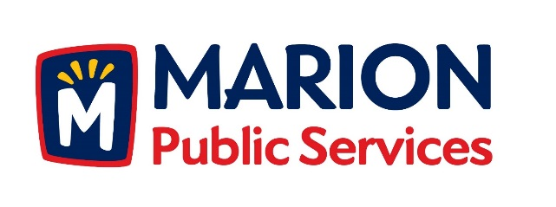

CITY OF MARION PUBLIC SERVICE BOARD
AGENDA
Noon
April 9th, 2019

- Motion to approve the March 2019 Minutes.

- Motion to approve job description for Deputy Director-Public Service Department.

- Discussion regarding Solid Waste and Sanitary Sewer Fee Schedules.

- Discussion regarding Solid Waste Management.

- Update on Phase I of the Eco Industrial Park.

- Old Business/New Business.

- Adjournment.

