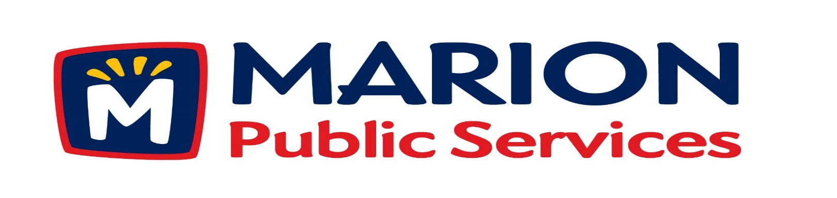
Minutes
Public Services Board
City of Marion
Tuesday, March 12th, 2019

Present: Tom Padley, Mark Morgan, and Craig Adamson

Absent: Colleen Prokop

Guest: Joe Spinks and Todd Hoppel – Anderson-Bogart

Staff: Ryan Miller and Diane Toy

- Motion to Approve the February 2019 Minutes.

- Motion to approve application for house collection services.
  - Bonebrake – 545 Central Avenue
- Motion to approve amendment to the Professional Services Agreement for the Eco Industrial park with Anderson-Bogart.

- Discussion regarding the grading project for Phase III of the Eco industrial Park.

- Old Business/New Business.

- Adjournment.

Minutes
Public Services Board
City of Marion
Tuesday, March 12th, 2019
Continued

ITEM 1 Approval of February 2019 Minutes.
Craig Adamson called to order the regular meeting of the Public Service Board on Tuesday, March 12th, 2019 at 12:05PM. A motion to approve the February 2019 minutes was made by, Mark Morgan seconded by Tom Padley, approved by all, Motion carried.

ITEM 2 Motion to approve applications for house collections services.
Ryan told the PS Board that the Solid Waste Supervisor went out to talk to the resident and recommends house pick up for the Mrs. Bonebrake, she is in her 90’s and has to walk down the alleyway to get her garbage to the curb.. A motion was made by Tom Padley to approve the applications for house collection service, seconded by Mark Morgan, approved by all members, Motion carried.

ITEM 3 Motion to approve amendment to the Professional Services Agreement for the Eco Industrial park with Anderson-Bogart.
Ryan introduced Todd Hoppel from Anderson-Bogart to the PS Board and Todd updated the PS Board about changes made to the Professional Services Agreement for the Eco Industrial Park. Anderson-Bogart will be responsible for staking through the construction, paving package and include site visits. The Agreement included some revisions since it was drafted in 2013. A motion was made by Mark Morgan to approve the Professional Services Agreement with Anderson-Bogart, seconded by Tom Padley, approved by all members, Motion carried.

Minutes
Public Services Board
City of Marion
Tuesday, March 12th, 2018
Continued

ITEM 4 Discussion regarding the grading project for Phase III of the Eco industrial Park.

Ryan update the PS Board on the grading project for Phase III of the Eco Industrial Park. The detention basin has an overflow plan to keep water on the property. The dirt taken out for the pond will be used for grading fill oat the Recycling Resource Center across from 44th St, we will move the dirt only once and save money and extra dirt will also be used for berms. Grade work bid date is 4/25/2019 due by 10:00AM. Craig Adamson wants to make sure there is a priority on the time line with penalties if not meet. Ryan will keep the PS Board updated on the progress.

ITEM 5 Old Business / New Business.
New Business: Ryan will have 3-D model of new drawing for the office and operations center from Knapp Warden.
Tent: had 2 new panels replaced on the tent by Legacy, the building is warmer and we still need to replace the installation. We are possibly looking into reusing the tent building for a new salt tent.
Site 2 at the Solid Waste Agency is going to do a capacity study, since the existing liner has capacity through mid-2022, they need to have a plan on what to do. Joe Horaney presented to the Marion City Council and they suggested that the Solid Waste Agency comes up with a plan B. Mark Morgan asked what are they planning to do? Ryan was not sure.
Tom Padley left at 12:50PM.
Sustane has been in talks with the Public Service Department since 2016 and they now have a plant that is up and running in Chester County, Nova Scotia. This company is more in line with solid waste recovery direction that the city is heading in. They will be out to visit with the Public Service Department this month, to talk about their plant and the process.

Minutes
Public Services Board
City of Marion
Tuesday, March 12th, 2018
Continued

ITEM 7 Adjournment.
The meeting was adjourned at 1:18PM by Craig Adamson. A motion was made by Craig Adamson, seconded by Mark Morgan, approved by all members, Motion carried.

Next PS Board meeting is scheduled for Tuesday, April 9th, 2019 at noon.

Respectfully submitted by:

____________________
Ryan Miller
Public Service Director

RM/dpt

