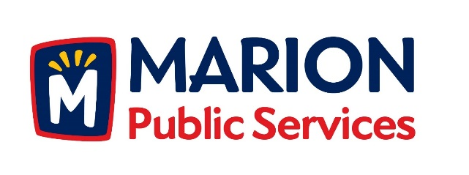

CITY OF MARION PUBLIC SERVICE BOARD
AGENDA
Noon
March, 12th 2019

- Motion to approve the February 2019 Minutes.

- Motion to approve applications for house collection services.

  - Bonebrake-545 Central Avenue

- Motion to approve amendment to the Professional Services Agreement for the Eco Industrial Park with Anderson-Bogert.

- Discussion regarding the grading project for Phase III of the Eco Industrial Park.

- Old Business/New Business.

- Adjournment.

