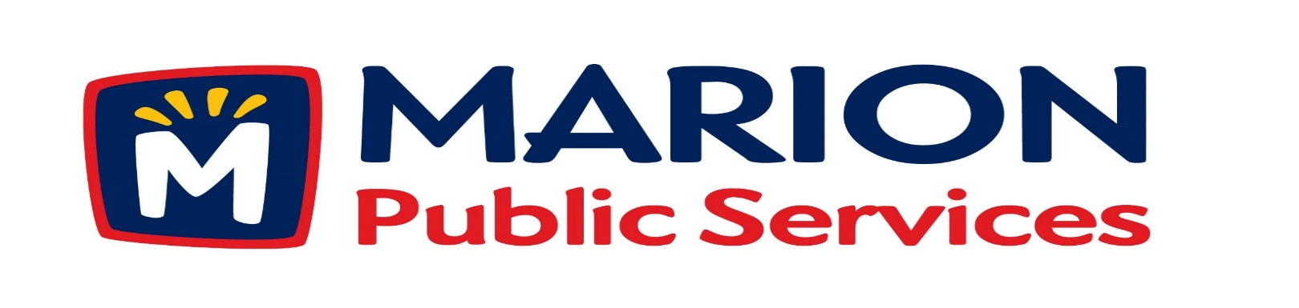
Minutes
Public Services Board
City of Marion
Tuesday, February 12th, 2019

Present: Colleen Prokop, Tom Padley, Mark Morgan, and Craig Adamson

Absent: Kevin Morgan

Staff: Ryan Miller and Diane Toy

- Motion to Approve the January 2019 Minutes.

- Motion to Approve applications for house collection services.
  - Ludlow 3340 Sunburst Ave
  - Jones 3330 Sunburst Ave
  - Gregorie 3105 Willowridge Rd Unit B
  - Henderson 3220 Sunburst Ave
- Motion to approve request for multifamily collection for 460-490 12th St.

- Motion to receive and file Public Services 2019-2020 Strategic Planning Objectives.

- Update on Public Services Maintenance Facility.

- Old Business/New Business

- Adjournment.

Minutes
Public Services Board
City of Marion
Tuesday, February 12th, 2019
Continued

ITEM 1 Approval of January 2019 Minutes.
Mark Morgan called to order the regular meeting of the Public Service Board on Tuesday, February 12th, 2019 at 12:05PM. A motion to approve the January 2019 minutes was made by Tom Padley, seconded by Colleen Prokop, approved by all, Motion carried.

ITEM 2 Motion to Approve applications for house collections services.
Ryan told the PS Board that the Solid Waste Supervisor went out to talk to the residents and recommends house pick up for the Ludlow, Jones, Gregorie, Henderson. A motion was made by Colleen Prokop to approve the applications for house collection service, seconded by Tom Padley, approved by all members, Motion carried.

ITEM 3 Motion to approve request for multifamily collection for 460-490 12th St.
Ryan would not recommend Solid Waste collection at 460-490 12th St. The reasons discussed were they have a dumpster and is working they may need to increase the number of times it is emptied. There is no good place to place the garbage cans, it is directly across the street from a school. A motion was made by Craig Adamson to not approve the request for City solid waste collection, seconded by Tom Padley, approved to deny request by all members, Motion to deny request carried.

Minutes
Public Services Board
City of Marion
Tuesday, February 12th, 2018
Continued

ITEM 4 Motion to receive and file Public Service 2019 -2020 Strategic Planning.
Ryan update the PS Board on the Strategic Planning session that was held out of 38 employees 20 employees attended the 2 day session, all employees were invited to attend. The session was led by Courtney from Kirkwood Community College. Our goal was to tie our vision back to the City of Marion’s goals, we used the Golden Circle which is to ask the Why, How, and What of your business. The PS employees came up with the following:
#1 New Building / Equipment Replacement
#2 Employee Training / Development Programs
#3 Evaluation of Service Delivery Models
#4 Development of PS Employee Manual
This will help employees with a handbook guide and include an operating protocol for overtime and department procedures. On Call number of operators needed for sanding is 10, plowing is 20 and solid waste operators are used in the PM operations and are the last ones called in for morning overtime. Streets department can have 6 operators off at one time, must keep operation levels and staffing levels met at all times, so having a reference would be a good thing to have so everyone has the information, the current City of Marion polices do not state this and the PS Department has different needs and are seasonal. The Strategic Plan will be reviewed every 2 years and reported back to the PS Board and we will tie this back to our work program. Other service departments within the city are already doing this or are working on doing this. The PS Board this is a very commendable project to take on and it is a good idea to have policies in writing. The position of a Deputy PS Director is in the budget and Ryan is working on the job description and filling the position. A motion was made receive and file Public Services 2019-2020 Strategic Planning Objectives. by Mark Morgan, seconded by Tom Padley, approved by all members, Motion carried.

Minutes
Public Services Board
City of Marion
Tuesday, February 12th, 2018
Continued

ITEM 5 Update on Public Services Maintenance Facility.
Ryan updated the PS Board on the progress of the maintenance plans and designs and that the project is in the current CIP budget. The plan is to have a building that will last a minimum of 40 years and we are looking at 4 different types of building, plan number 4 has a life cycle of 74 years (which is double the life cycle of the other 3 building styles) but cost more. We are looking into all factors before we have a final recommendation for the PS Board and the City Council. The design team is looking at the interior FFE, Fixtures and furniture. The number of program days are in the contract and will be monitored by the Construction Project Management (CPM). Ryan will keep the PS Board updated on the progress and at a future meeting the design team and CPM.

ITEM 6 Old Business / New Business.
Ryan discussed the upcoming Medco Lunch: Craig, Tom, Ryan - Yes
Colleen and Mark – No

Update on the salt situation: smaller cities are out, we are okay have ordered more and are watching the terminal supply closely.
Watching SW and Sewer rates may have to increase fees. We are hoping for a possible Letter of Intent with the CR/LC Solid Waste Agency.
Maybe a meeting and or presentation from Sustane Technologies.
PS tent repairs are scheduled to start on Wednesday 2/13/19 by Legacy and they will be able to shore up the building and we may be able to use it in the future as an additional salt building.

Minutes
Public Services Board
City of Marion
Tuesday, February 12th, 2018
Continued

ITEM 7 Adjournment.
The meeting was adjourned at 1:12PM by Mark Morgan. A motion was made by Colleen Prokop, seconded by Tom Padley, approved by all members, Motion carried.

Next PS Board meeting is scheduled for Tuesday, March 12th, 2019 at noon.

Respectfully submitted by:

____________________
Ryan Miller
Public Service Director

RM/dpt

