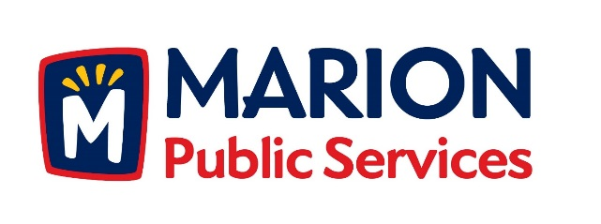

CITY OF MARION PUBLIC SERVICE BOARD
AGENDA
Noon
February 12th, 2019

- Motion to approve the January 2019 Minutes.

- Motion to approve applications for house collection services.

  - Ludlow 3340 Sunburst Avenue
  - Jones 3330 Sunburst Avenue
  - Gregorie 3105 Willowridge Rd. Unit B
  - Henderson 3220 Sunburst Avenue

- Motion to approve request for multifamily collection for 460-490 12th Street.

- Motion to receive and file Public Services 2019-2020 Strategic Planning Objectives.

- Update on Public Services Maintenance Facility.

- Old Business/New Business.

- Adjournment.

