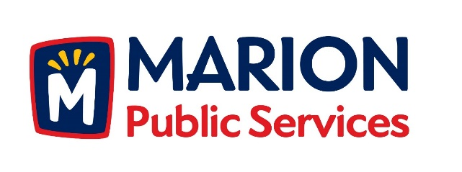

CITY OF MARION PUBLIC SERVICE BOARD
AGENDA
Noon
January 8th, 2019

- Motion to approve the December 2018 Minutes.

- Motion to approve the 2019 Solid Waste Holiday Collection Calendar.

- Motion to Receive and File the Commercial New Construction Program Report from The Weidt Group.

- Discussion regarding the Public Service Maintenance Facility.

- Motion to Approve Letter of Intent with Sustane Technologies.

- Old Business/New Business.

- Adjournment.

