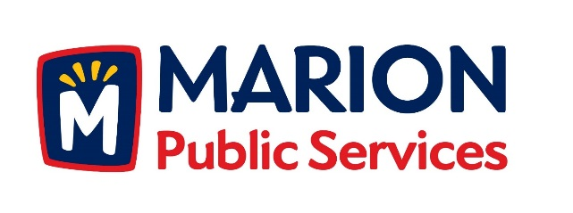

CITY OF MARION PUBLIC SERVICE BOARD
AGENDA
Noon
November 13th, 2018

- Motion to approve the October 2018 Minutes.

- Motion to approve the 2018-2019 Snow Removal Program.

- Review of the proposed 2018 Capital Improvement Program.

- Update on Phase I of the Eco Industrial Park.

- Old Business/New Business.

- Adjournment.

