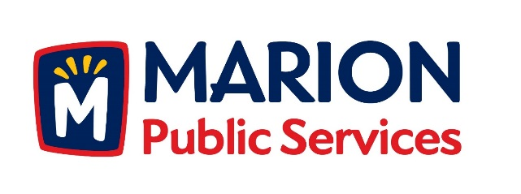

CITY OF MARION PUBLIC SERVICE BOARD
AGENDA
Noon
December 11th, 2018

- Motion to approve the November 2018 Minutes.

- Discussion regarding storm water improvements at 2401 Indian Creek Road (Indian Creek Country Club).

- Discussion regarding the Public Service Maintenance Facility.

- Review of 2019-2020 Fiscal Year Budget.

- Discussion regarding vacancy for the Public Services Board.

- Old Business/New Business.

- Adjournment.

