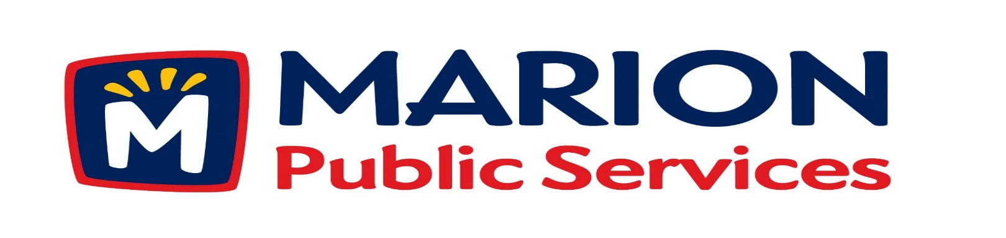
Minutes
Public Services Board
City of Marion
Tuesday, December 11th, 2018

Present: Colleen Prokop, Tom Padley, Mark Morgan, and Craig Adamson

Absent: Kevin Morgan

Staff: Ryan Miller and Diane Toy

- Motion to approve the November 2018 Minutes.

- Discussion regarding storm water improvements at 2401 Indian Creek Road (Indian Creek Country Club).

- Discussion regarding the Public Service Maintenance Facility.

- Review of 2019-2020 Fiscal Year Budget.

- Discussion regarding vacancy for Public Services Board.

- Old Business/New Business.

- Adjournment.

Minutes
Public Services Board
City of Marion
Tuesday, December 11th, 2018
Continued

ITEM 1 Approval of November 2018 Minutes.
Craig Adamson called to order the regular meeting of the Public Service Board on Tuesday, December 11th, 2018 at 12:10PM. A motion to approve the November 2018 minutes was made by Mark Morgan, seconded by Colleen Prokop, approved by all, Motion carried.

ITEM 2 Discussion regarding storm water improvements at 2401 Indian Creek Road (Indian Creek Country Club).
Ryan updated the PS Board on the storm water improvements for 2401 Indian Creek Road, letter is attached for reference. The storm water ditch is off the 1st hole and the City is responsible for the maintenance, since 2008 when the housing development went in. The Indian Creek Country Club wants the city to place an encased pipe and they will plant wild flowers and maintain. Ryan stated we can do this but would take many man hours to do. We have a few options: 1) access the property about 300 feet and would put an encased pipe in existing ditch and cover with dirt, Indian Creek Country Club would seed and do finish work. Ryan said the earliest the work can be done is fall or winter 2019 and he needs to look into cost and estimated man hours. 2) Craig would like to see the work bid out and the PS Board asked the question the system is working why change it? 3) Mark is concerned about the cost to the city. The PS Board is not unanimously for or against the project. The PS Board would like Ryan to see how much the project would cost and see it the Indian Creek Country Club would share the cost. The PS Board wanted to know if they looked into making it a rain garden to slow down the flow of the water. A motion was made by Mark Morgan have Ryan get back to the PS Board with numbers and talk about the request at that time, seconded by Colleen Prokop, approved by all members, Motion carried.

Minutes
Public Services Board
City of Marion
Tuesday, December 11th, 2018
Continued

ITEM 3 Discussion regarding the Public Service Maintenance Facility.
Ryan update the PS Board on the progress of the Public Service Maintenance Facility and the plan is moving forward. The project is funded and on the CIP for 2019. Our cost is lower than Cedar Rapids and Iowa City’s facilities. Ryan discussed three options for the building with the PS Board and the costs are still within budget, they need to finalize which type of building to build and move forward with the plan. Ryan is starting to get the hard numbers from the Construction Manager from contractors. The PS Board discussed the roof and drains and wanted Ryan to bring their questions to the design team. Ryan will get back to the PS Board with an update.

ITEM 4 Review of 2019-2020 Fiscal Year Budget.
Ryan update the PS Board on the progress reviewing the Solid Waste fees and the current refuse collection program and discussed other options for the future and growth of the city, our current rates of $14.50 per month are the lowest in the state for cities of our size. Ryan is still looking at options and we would have to raise the fees if we go to automated collections. The cost for the automated cans is high and that would be the reason to increase the cost of the service to cover the cost of the cans. We have not raised the fee for bulk collection in 7 years. Ryan also is looking at modifications to the sanitary sewer fees and discussed different options with the PS Board. New skid loader replacement program cost is controlled and would get a new skid loader every year. We are working on closing the Hanna Park concrete dumping area and moving it to our property off 44th ST next to Rathje Construction and we are taking our asphalt milling to the landfill where it will be used to make roads.

ITEM 6 Old Business / New Business.
Ryan discussed candidates for the replacement of Kevin Morgan place on the PS Board and will discuss the candidates with the PS Board next month.
Minutes
Public Services Board
City of Marion
Tuesday, December 11th, 2018
Continued

ITEM 6 Old Business / New Business.
Reappointment for 2019-2020 Tom Padley – Yes, Mark Morgan – Yes, Collen Prokop – Yes
See attached approval from City Council.
The Public Service Department did a strategic planning session and we came up with 7-8 goals and we will have a follow up on the progress on the goals.

ITEM 7 Adjournment.
The meeting was adjourned at 1:33PM by Craig Adamson. A motion was made by Tom Padley, seconded by Mark Morgan, approved by all members, Motion carried.

Next PS Board meeting is scheduled for Tuesday, January 8th, 2019 at noon.

Respectfully submitted by:

____________________
Ryan Miller
Public Service Director

RM/dpt

