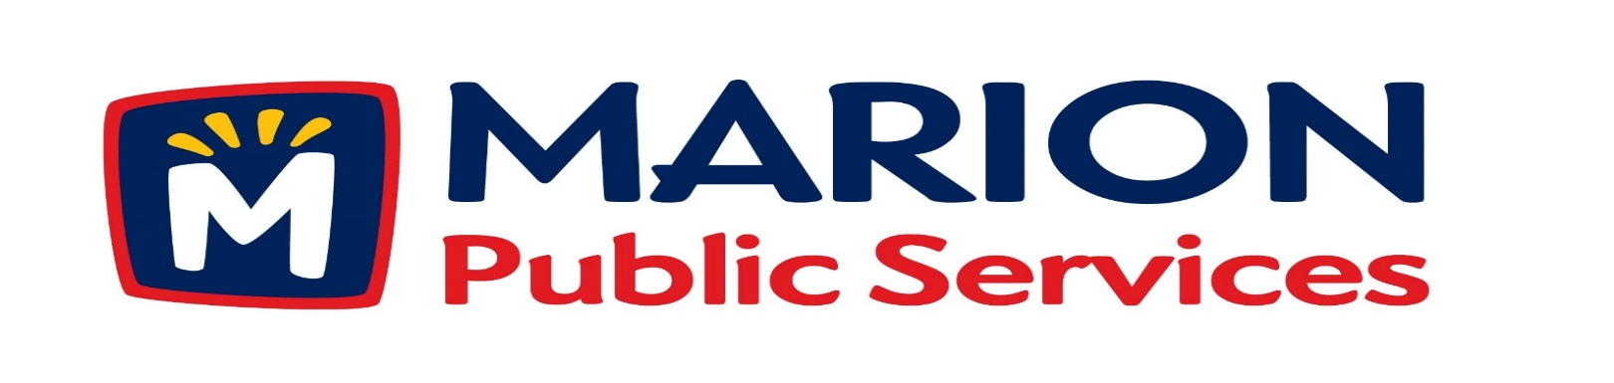
Minutes
Public Services Board
City of Marion
Tuesday, October 21st, 2018

Present: Colleen Prokop, Tom Padley, and Mark Morgan
Absent: Craig Adamson and Kevin Morgan
Staff: Ryan Miller and Diane Toy

- Motion to approve the August 2018 Minutes.

- Motion to approve application for house pickup services:
  - Patterson – 1505 Maplecrest Drive
  - Henderson – 3220 Sunburst Avenue

- Discussion regarding capacity study for the Solid Waste Agency.

- Update on Phase I of the Eco Industrial Park.

- Old Business/New Business.

- Adjournment.

Minutes
Public Services Board
City of Marion
Tuesday, October 21st, 2018
Continued

ITEM 1 Approval of August 2018 Minutes.
Tom Padley called to order the regular meeting of the Public Service Board on Tuesday, October 9th, 2018 at 12:07PM. A motion to approve the August 2018 minutes was made by Mark Morgan, seconded by Colleen Prokop, approved by all, Motion carried.

ITEM 2 Approve application for house pickup.
Ryan updated the PS Board on house pick up requests from residents and said staff has recommended house pickup for Mr. & Mrs. Patterson who resides at 1505 Maplecrest Dr. who have problems walking and cannot get the garbage and recycling to the curb safely. Mrs. Henderson who resides at 3220 Sunburst Ave daughter requested house pick up for her mother who is 90 years old. Terry has not been out to speak with her yet. The PS Board would like to look into the current rules for requesting house pick up. The house pickup request for Nash who resides at 3365 Willowridge Rd, Unit D and Orcutt 3365 Willowridge Rd, Unit C the PS Board would like more information on these residents as to the reason for the service. We will let the Solid Waste supervisor know and bring the information to the next PS board meeting. Ryan talked to the PS Board that the resident do meet the current requirement for house pick up. A motion was made by Mark Morgan to approve all house pick up requests, seconded by Colleen Prokop, approved by all members, Motion carried.

Minutes
Public Services Board
City of Marion
Tuesday, October 21st, 2018
Continued

ITEM 3 Discussion regarding capacity of the Eco Industrial Park.
Ryan talked to the PS Board about the Capacity study of the Solid Waste Agency site 2 and Settlement agreement of 2002. Issues that the landfill is filling up faster than anticipated and only have capacity until 2022, some options are:
1 – Modify Site 2 – would like to change the height of the landfill.
2 – Site another location in Linn County.
3 – Change to a transfer station, but they are not currently setup for this kind of operation.
The members for the PS Board has questions: Can we hold them back from any of the above options. Ryan said that the City of Marion will annex that section of town and they will be under the City’s Planning and Zoning ordinance. This will stop them from moving the compost facility from Site 1 to Site 2. There is a closure agreement for the landfill that takes about 10 years and the end date is 2040. There are some solid waste companies that do transfer their solid waste to Illinois because it is cheaper than using the landfill, but not sure how long that would be the case. The City of Marion is looking at all options and taking their time making any decisions. Ryan will keep the PS Board updated on the progress of the plans for the Solid Waste Agency.

ITEM 4 Update on Phase I of the Eco Industrial Park.
Ryan update the PS Board on the state of the blue tent used for equipment storage, the lattice work is where the repairs have been made. There have been some more rips but only on the blue panels of the tent, and we have repaired them so the tent will make it through the winter, which this will be the last one. Eco Industrial site plan has been complete and we are looking at the site design. WE are looking at a very large geothermal system and the rebate will be higher from Aliant, the study was done by the Weidt Group. The project is moving along and still within budget. Ryan will keep the PS board updated on the progress of the project and have Knapp Worden present to the PS Board at a later date.
Minutes
Public Services Board
City of Marion
Tuesday, October 21st, 2018
Continued

ITEM 5 Old Business / New Business.
Update on the Library project, uptown parking, move the Vintage Urban house.
The old cement plant was taken down.
The trail behind the new hotel is being worked on.
IC Country Club is asking the PS Department to help put in a closed pipe in the easement for drainage of storm water. The City Council is looking into this and not sure what to do so they may pass it on to the PS Board. A possible solution maybe cost sharing.
ITEM 8 Adjournment.
The meeting was adjourned at 1:35 PM by Tom Padley. A motion was made by Tom Padley, seconded by Colleen Prokop, approved by all members, Motion carried.

Next PS Board meeting is scheduled for Tuesday, November 13th, 2018 at noon.

Respectfully submitted by:

____________________
Ryan Miller
Public Service Director

RM/dpt

