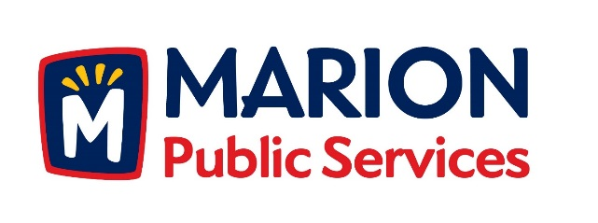

CITY OF MARION PUBLIC SERVICE BOARD
AGENDA
Noon
October 9th, 2018

- Motion to approve the August 2018 Minutes.

- Motion to approve application for house pickup services.

a.Patterson-1505 Maplecrest Drive

- Discussion regarding capacity study for the Solid Waste Agency.

- Update on Phase I of the Eco Industrial Park.

- Old Business/New Business.

- Adjournment.

