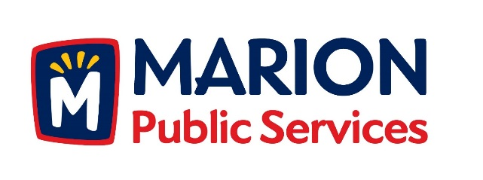

CITY OF MARION PUBLIC SERVICE BOARD
AGENDA
Noon
September 11th, 2018

- Motion to approve the August 2018 Minutes.

- Discussion regarding house collection services.

- Discussion regarding equipment procurement program.

- Update on Phase I of the Eco Industrial Park.

- Old Business/New Business.

- Adjournment.

