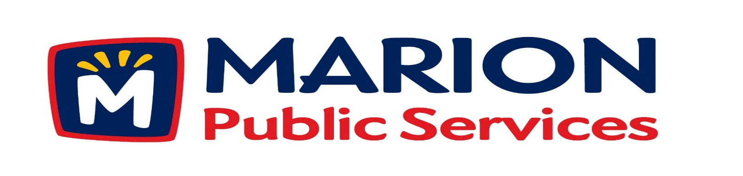
Minutes
Public Services Board
City of Marion
Tuesday, August 21st, 2018

Present: Colleen Prokop, Tom Padley, Craig Adamson and Mark Morgan arrived at 12:13pm
Absent: Kevin Morgan
Staff: Ryan Miller and Diane Toy

- Motion to approve the July 2018 Minutes.

- Motion to approve application for house pickup services:
  - Arp-2450-28th Avenue
  - Wroblewski 2170 27th Street
  - Nash-3365 Willowridge Rd. Unit D
  - Orcutt-3365-Willowridge Rd. Unit C

- Motion to consider collection and storage of donated railroad items from Burnum 2540 22nd Avenue. (Marion Historical Society, 590 10th Street).

- Review of proposed Wastewater Treatment Agreement from the City of Cedar Rapids.

- Discussion regarding Strategic and Operational Planning for the Public Services Department.

- Update on Phase I of the Eco Industrial Park.

- Old Business/New Business.

- Adjournment.

Minutes
Public Services Board
City of Marion
Tuesday, August 21st, 2018
Continued

ITEM 1 Approval of July 2018 Minutes.
Craig Adamson called to order the regular meeting of the Public Service Board on Tuesday, July 10th, 2018 at 12:07PM. A motion to approve the July 2018 minutes was made by Tom Padley, seconded by Colleen Prokop, approved by all, Motion carried.

ITEM 2 Approve application for house pickup.
Ryan updated the PS Board on house pick up requests from residents and said staff has recommended house pickup for Arp who resides at 2450 28th Ave who use a walker and Wroblewski who resides at 2170 27th St who has health issues and cannot get the garbage and recycling to the curb safely. The PS Board would like to look into the current rules for requesting house pick up. A motion was made by Tom Padley to move approve the house pickup request for Arp and Wroblewski, seconded by Colleen Prokop, approved by all members, Motion carried. The house pickup request for Nash who resides at 3365 Willowridge Rd, Unit D and Orcutt 3365 Willowridge Rd, Unit C the PS Board would like more information on these residents as to the reason for the service. We will let the Solid Waste supervisor know and bring the information to the next PS board meeting. A motion was made by Tom Padley to move getting more information on the house pickup request for Nash and Orcutt, seconded by Colleen Prokop, approved by all members, Motion carried.

Minutes
Public Services Board
City of Marion
Tuesday, August 21st, 2018
Continued

ITEM 3 Motion to consider collection and storage of donated railroad items from Burnum 2540 22nd Avenue (Marion Historical Society, 590 10th Street).
Ryan talked to the PS Board about the railroad items the Marion Historical Society would like the PS Department t go and pick up and store for them that are located in the back yard of 2540 22nd Avenue. Craig and the other PS Board members had concerns about this and wanted answer to the following concerns. They want the Marion Historical Society to sign a Hold Harmless agreement for the moving and storing of the items it is decided that we do this.
When do we fit this into our workday? How are they workers recognized to do this and would it be during work hours or would they volunteer their time? They also want to know who decides what to accept and store? Do we have a place to store these items or would they be left outside. The PS Board would like Ryan to go back to the Marion Historical Society and say we do not feel this is something the PS Department should be doing during working hours and not be responsible to store these kind of items on city property. The PS Board would like Ryan to get more information on the items and are asking for a formal plan that is submitted in writing. A vote as stands, A motion as letter is submitted: Yays – none, Nays: Colleen Prokop, Tom Padley, Mark Morgan and Craig Adamson.

ITEM 4 Review of proposed Wastewater Treatment Agreement from the City of Cedar Rapids.
Ryan updated the PS Board about the progress of the talks with the City of Cedar Rapids, that we are closer to an agreement since they have been monitoring the flow meters for accurate information, we are still under the agreement signed in 1978. Ryan would like to see developers pay towards increased capacity fee. Ryan’s recommends a charge to the developer for each new lot developed 250 gals per day per lot. We need to charge people what we are using not a flat fee and that we found out the industrial use is higher than we expected. The goal is to be charged for what we are using. Ryan will keep the PS Board updated on the progress of signing a new agreement with the City of Cedar Rapids.

Minutes
Public Services Board
City of Marion
Tuesday, August 21st, 2018
Continued

ITEM 5 Discussion regarding Strategic and Operational Planning for Public Services Department.
Ryan gave the PS Board back ground on how strategic and operational planning was used in the past and how it lacked substance and accountability. The City of Marion’s new strategic plan is 1 page with 5 elements, which is easy to read and understand. Ryan is working on a draft outline for the PS Department that would include: A Vision, A Mission, City Statistics and Goals. The Police Department just presented a 5 year plan to the City Council. Ryan wants to know what the PS Board thinks and would they want to be a part of this? Many Cities have a plan but not for individual departments. If the PS Board feels this is a valuable process, Ryan would like a facilitator to create the final document. The PS Board will come up with a plan of action and wants Ryan to keep moving forward.
ITEM 6 Update on Phase I of the Eco Industrial Park.
Ryan update the PS Board on the progress of Phase I of the Eco Industrial Park. The goal is to have the footings in this fall, and so far all costs for everything is within budget. The gas is connected and Ryan had a meeting with Mid AM about the CNG today. Everything is coming together and will have a 3-d design to do a walk through with Knapp Worden. Ryan will have then attend a PS Board meeting at that time. Ryan will continue to keep the PS Board update on the project.
ITEM 7 Old Business / New Business.
Parks will be responsible to clear the snow from the new trails and the city has money for future trail use.
New business opened Bristro 3 Nineteen and they had a soft opening on 8/21/2018 and will open for business on 8/22/18.
PS Board thinks the new parking lot at 8th Ave & 12th St is great.
ITEM 8 Adjournment.
The meeting was adjourned at 1:30 PM by Craig Adamson. A motion was made by Tom Padley, seconded by Colleen Prokop, approved by all members, Motion carried.

Minutes
Public Services Board
City of Marion
Tuesday, August 21st, 2018
Continued

Next PS Board meeting is scheduled for Tuesday, September 11th^{th}, 2018 at noon.
Respectfully submitted by:

____________________
Ryan Miller
Public Service Director

RM/dpt

