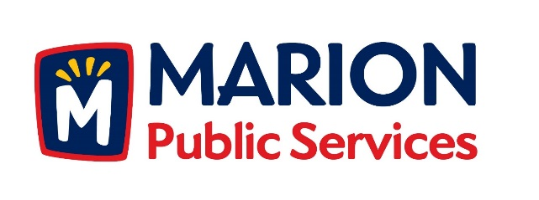

CITY OF MARION PUBLIC SERVICE BOARD
AGENDA
Noon
August 21st, 2018

- Motion to approve the July 2018 Minutes.

- Motion to approve application for house pickup services:
  - Arp-2450-28th Avenue
  - Wroblewski 2170 27th Street
  - Nash-3365 Willowridge Rd. Unit D
  - Orcutt-3365-Willowridge Rd. Unit C

- Motion to consider collection and storage of donated railroad items from Burnum 2540 22nd Avenue. (Marion Historical Society, 590 10th Street).

- Review of proposed Wastewater Treatment Agreement from the City of Cedar Rapids.

- Discussion regarding Strategic and Operational Planning for the Public Services Department.

- Update on Phase I of the Eco Industrial Park.

- Old Business/New Business.

- Adjournment.

