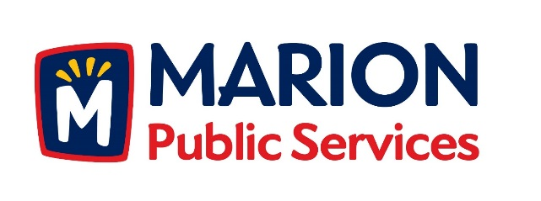

CITY OF MARION PUBLIC SERVICE BOARD
AGENDA
Noon
July 10th, 2018

- Motion to approve the June 2018 Minutes.

- Motion to approve application for house pickup services:
  - Johnson-1215 Northview

- Update on Phase I of the Eco Industrial Park.

- Discussion regarding Verizon Wireless Small Cell Project.

- Old Business/New Business.

- Adjournment.

