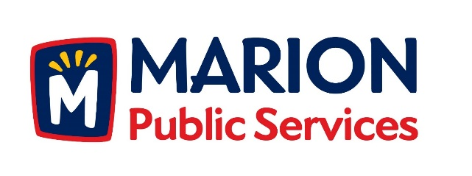

CITY OF MARION PUBLIC SERVICE BOARD
AGENDA
Noon
June 19th, 2018

- Motion to approve the May 2018 Minutes.

- Discussion regarding Phase I of the Eco Industrial Park.

- Motion to approve Knapp Warden as Construction Manager for the Public Service Maintenance Facility.

- Update on Solid Waste Rates for Commercial Collection Services

- Old Business/New Business.

- Adjournment.

