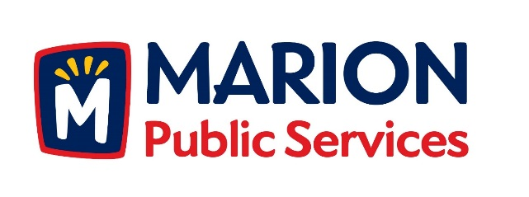

CITY OF MARION PUBLIC SERVICE BOARD
AGENDA
Noon
May 8th, 2018

- Motion to approve the April 2018 Minutes.

- Review of Solid Waste Rates for Commercial Collection Services.

- Discussion regarding Request for Proposals for Construction Manager Services.

- Old Business/New Business.

- Adjournment.

