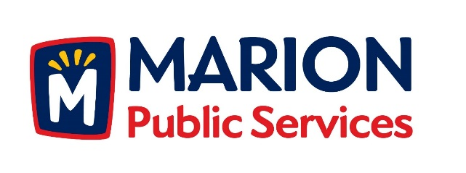

CITY OF MARION PUBLIC SERVICE BOARD
AGENDA
Noon
April 10th, 2018

- Motion to approve the March 2018 Minutes.

- Motion to approve residency waiver for Mike Devlin.

- Motion to approve application for house pickup services:

a. Melcherd-2400 23rd Avenue

- Motion to Approve Request for Solid Waste Exemption.

a.Lange-261 Larick Drive

- Motion to approve the 2018 work schedule for the Public Services Department.

- Update on the Eco Industrial Park.

- Old Business/New Business.

- Adjournment.

