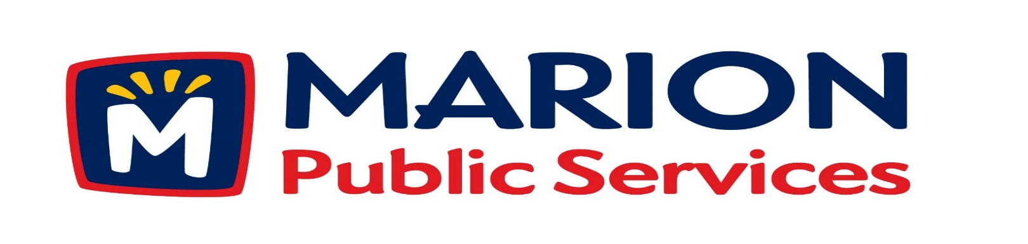
Minutes
Public Services Board
City of Marion
Tuesday, March 13th, 2018

Present: Colleen Prokop, Tom Padley, Craig Adamson, and Mark Morgan
Absent: Kevin Morgan
Staff: Ryan Miller and Diane Toy

- Approval of February 2018 Minutes.

- Motion to approve application for house pick-up service: a. Sumner – 1875 9th Avenue b. Long – 1125 Elim Drive Unit A
c. Crutchley – 1125 Elim Drive Unit D
d. Boynton – 3345 Sunburst Avenue
- Discussion regarding Wastewater Treatment Agreement with City of Cedar Rapids.
- Update on Eco Industrial Park.
- Old Business / New Business.
- Adjournment.
Minutes
Public Services Board
City of Marion
Tuesday, March 13th, 2018
Continued

ITEM 1 Approval of February 2018 Minutes.
Mark Morgan called to order the regular meeting of the Public Service Board on Tuesday, March 13th, 2018 at 12:10PM, Craig Adamson arrived at 12:20PM. A motion to approve the February 2018 minutes was made by Tom Padley, seconded by Colleen Prokop, approved by all, Motion carried.

ITEM 2 Motion to approve application for house pick-up services.
Ryan updated the PS Board that the following residents have requested house pickup at their residences: Sumner 1875 9th Avenue, Long 1125 Elim Drive Unit A, Crutchley 1125 Elim Drive Unit D, Boynton 3345 Sunburst Avenue. Staff has gone out and spoke with them and have requested house pick-up for all of them. A motion was made by Tom Padley, seconded by Colleen Prokop to approve house pickups for all residences, approved by all members, Motion carried.

ITEM 3 Discussion regarding Wastewater Treatment Agreement with City of Cedar Rapids.
Ryan updated the PS Board on where we are on the agreement with the City of Cedar Rapids on the Wastewater Treatment Agreement working on terminology for the right to connect is correct and then it will go to community leaders to make sure everyone agrees. The new agreement is Phase I and starts in July 2018 and Phase II will start in July 2021. Our sewer rates are very low compared to other cities: Marion’s high user pays $33.00, Urbandale pays $28.00 and Cedar Falls pays $35.00. Below is the cost breakdown each month for O & M charges and capacity fees, capacity charges are set on the number of residents that is calculated at a rate per resident.
New Agreement 7/2018 O & M Capacity Fees MTHLY TOTAL
$130,799.90 $116,307.10 $247,107.00
Phase II 7/2021 $138,494.90 $57,772.66 $196,267.56

Minutes
Public Services Board
City of Marion
Tuesday, March 13th, 2018
Continued

ITEM 3 Discussion regarding Wastewater Treatment Agreement with City of Cedar Rapids continued.
Craig and the PS Board would like Ryan to see if he can negotiate a lower rate, since we have overpaid for years on capacity, since this agreement is flow based we have installed flow meters to track our flow amounts and have a few years’ worth of data. Ryan explained that some of the cost increase is due to getting us to the Recommended Standards for Wastewater Facilities. The current City Council will have a very hard time accepting these numbers and may wantto see if we can negotiate our fees or maybe hire a consultant to look into other options. Ryan will keep the PS Board updated as talks continue. Craig asked what the lifespan of the wastewater treatment plant is and why is City of Cedar Rapids adding 25% to the cost of monthly capacity charges.

ITEM 4 Update on the Eco Industrial Park.
Ryan has updated the PS Board on plans for the new PS building. We are getting close to the final plans, there are just a few details to sort out, trying to cover future expansion from the onset. Grading is complete and utilities are being scheduled for installation. Mid America is ready for installation of the gas line. The schedule is to get steel up this year and work on the inside in a year. We will pursue this project by the Iowa State code. Ryan will keep the PS Board updated about the plans and developments at future meetings.

ITEM 5 Old Business / New Business
Ryan answered questions about the Kwik Star plans at HWY 151 & 13 and where other Kwik Star locations will be within the city of Marion. Update on the projects around town.

Minutes
Public Services Board
City of Marion
Tuesday March 13th, 2018
Continued

ITEM 6 Adjournment.
The meeting was adjourned at 1:30 PM by Mark Morgan. A motion was made by Mark Morgan, seconded by Craig Adamson, approved by all members, Motion carried.

Next PS Board meeting is scheduled for Tuesday, April 10th, 2018 at noon.

Respectfully submitted by:

____________________
Ryan Miller
Public Service Director

RM/dpt

