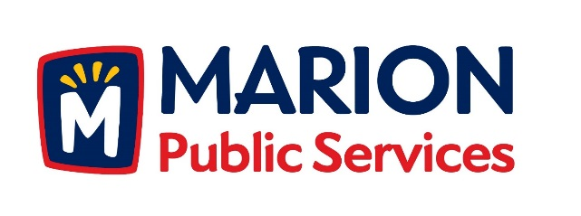

CITY OF MARION PUBLIC SERVICE BOARD
AGENDA
Noon
March 13th, 2018

- Motion to approve the February 2018 Minutes.

- Motion to approve application for house pickup services:

a. Sumner-1875 9th Avenue
b. Long-1125 Elim Drive Unit A
c. Crutchley-1125 Elim Drive Unit D
c. Boynton-3345 Sunburst Avenue

- Discussion regarding Wastewater Treatment Agreement with City of Cedar Rapids.

- Update on the Eco Industrial Park.

- Old Business/New Business.

- Adjournment.

