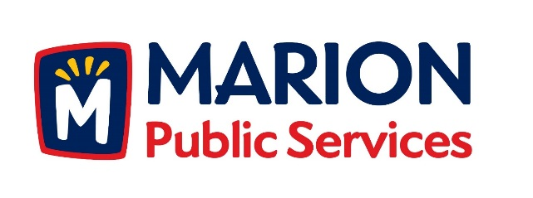

CITY OF MARION PUBLIC SERVICE BOARD
AGENDA
Noon
February 13th, 2018

- Motion to approve the January 2018 Minutes.

- Motion to approve application for house pickup services:

a. Lutz - 1620 Park Avenue
b. Dallege - 3355 Sunburst Avenue

- Review Citizen Claims:

  - Clay – 1005 Edwin Drive

- Motion to Amend Commercial Service Collection Rates.

- Old Business/New Business.

- Adjournment.

