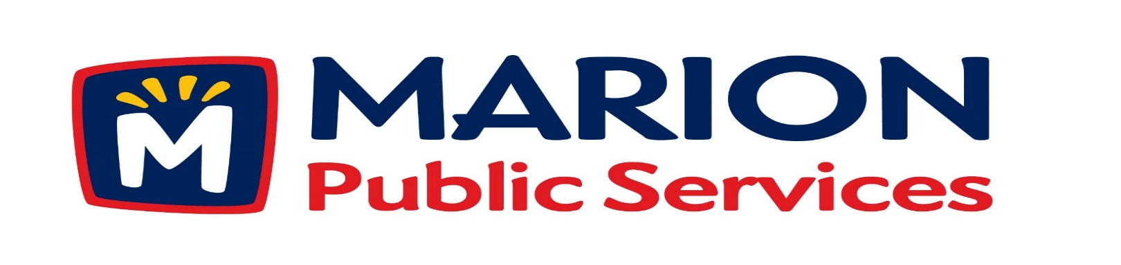
Minutes
Public Services Board
City of Marion
Tuesday, December 12th, 2017

Present: Craig Adamson, Colleen Prokop, Tom Padley, Kevin Morgan, and Mark Morgan
Absent: None
Staff: Ryan Miller and Diane Toy

- Approval of November 2017 Minutes.

- Motion to approve application for house pick-up service. (Gerber 2010 28th Avenue).
- Motion to approve refund for solid waste fees. (Harriott – 345/2365 5th Avenue).
- Motion to approve claims for damaged recycling and solid waste receptacles. (Rhodes – 1150 Bedford Court).
- Discussion regarding Request for Proposals for Eco Industrial Park Phase I.
- Old Business / New Business.
- Adjournment.
Minutes
Public Services Board
City of Marion
Tuesday, December 12th, 2017
Continued

ITEM 1 Approval of November 2017 Minutes.
Craig Adamson called to order the regular meeting of the Public Service Board on Tuesday, December14th, 2017 at 12:08PM. A motion to approve the November 2017 minutes was made by Mark Morgan, seconded by Tom Padley, approved by all, Motion carried.

ITEM 2 Motion to approve application for house pick-up services.
Ryan updated the PS Board that the Gerber have requested house pick up at their resident 2010 28th Street. Staff has gone out and spoke with them and have requested house pick-up, they are elderly and cannot get the garbage to the curb safely. A motion was made by Mark Morgan, seconded by Colleen Prokop, approved by all members, Motion carried.

ITEM 3 Motion to approve refund for solid waste fees.
Ryan updated the PS Board on the change of ownership in the rental units at 2345 / 2365 5th Avenue. The new owner hired a private solid waste company to place a dumpster between the 2 units and not use curb side solid waste pickup. He did not fill out the proper paper work, or go through the proper procedures, it is the owner’s responsibility to make sure the paper work is turned into Public Service. If the PS Board approves this request the property will not be able to have city solid waste pickup. Craig suggested proof of all invoices from the private solid waste collection company. Affirmative motion to approve to file the request. A motion was made by Craig Adamson, seconded by Mark Morgan, affirmative motion passed. PS Board voted on request for refund, motion failed 5 nay, 0 for. Nay votes Craig Adamson, Kevin Morgan, Mark Morgan, Tom Padley, and Colleen Prokop.

Minutes
Public Services Board
City of Marion
Tuesday, December 12th, 2017
Continued

ITEM 4 Motion to approve claim for damaged recycling and solid waste receptacles. (Rhodes – 1150 Bedford Court).
Ryan has updated the PS Board on the conversation he has had with Mr. Rhodes and the request received on the Public Service website doesn’t give us any backup, pictures or receipts and we need more information. We can offer Mr. Rhodes a used recycle bin and garbage can, and Ryan let him know he cannot have a wheeled recycle bin. A motion was made by Craig Adamson, seconded by Colleen Prokop, affirmative motion passed. PS Board voted on request to replace damaged cans with a Rubbermaid garbage can and a wheeled recycle bin, motion failed 5 nay, 0 for. Nay votes Craig Adamson, Kevin Morgan, Mark Morgan, Tom Padley, and Colleen Prokop. The PS Board would like Ryan to follow up with Mr. Rhodes and update the PS Board at the next meeting.

ITEM 5 Discussion regarding Request for Proposals for the Eco Industrial Park Phase I.
Ryan up dated the PS Board on the Eco Industrial park Phase I, we are at a standstill at the moment as the Master Builders attorney talks to our attorney about Chapter 26 law of Iowa. This allows you to look at the actual cost of the project s and we will get to see all the bids and we will have a say in the subs choose, this allows you to have control over the project. This would be Construction Manager Agency verses Construction Manager at Risk, is very transparent way to run a project. Ryan will update the PS Board after the attorneys have drafted the new paperwork. We are still waiting on core sample information.
Craig Adamson left the meeting at 1:00PM and Tom Padley took over as Chair.

ITEM 6 Old Business / New Business
Old Maidrite Building has major structural problem that can be fixed but will be very expensive. The bank now owns the Old Maidrite building and the lot at 1204 7th Ave. Flashing has been placed over the falling brick to make it safe until determined what to do and the scaffolding has been removed from the sidewalk.
Full depth asphalt overlay is 6 inches deep, this is very economical way to repair streets especially in residential areas.
Minutes
Public Services Board
City of Marion
Tuesday, December 12th, 2017
Continued

ITEM 7 Adjournment.
The meeting was adjourned at 1:31 PM by Tom Padley. A motion was made by Tom Padley, seconded by Colleen Prokop, approved by all members, Motion carried.

Next PS Board meeting is scheduled for Tuesday, January 9th, 2018 at noon.

Respectfully submitted by:

____________________
Ryan Miller
Public Service Director

RM/dpt

