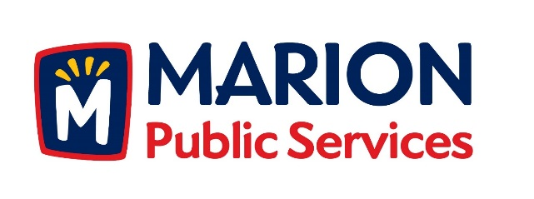

CITY OF MARION PUBLIC SERVICE BOARD
AGENDA
Noon
January 9th, 2018

- Motion to approve the December 2017 Minutes.

- Motion to approve application for house pickup services:

a. Betzer-600 West 8th Avenue
b. Davin-1840 Hillview

- Motion to approve the 2018 Holiday Schedule for Solid Collections.

- Discussion regarding organizational structure for Public Service.

- Motion to receive and file correspondence from the City of Cedar Rapids (Wastewater Treatment Charges for 2018/2019).

- Discussion regarding 2018-2019 Fiscal Year Budget.

- Old Business/New Business.

- Adjournment.

