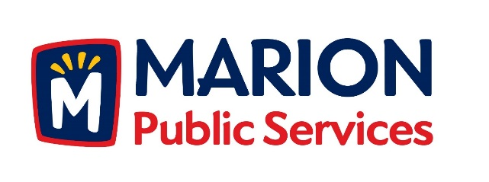

CITY OF MARION PUBLIC SERVICE BOARD
AGENDA
Noon
December 12th, 2017

- Motion to approve the November 2017 Minutes.

- Motion to approve application for house pickup services (Gerber-2010-28th Avenue).

- Motion to approve refund of solid waste fees. (Harriott -2345/2365 5th Avenue).

- Motion to approve claims for damaged recycling and solid waste receptacles (Rhodes-1150 Bedford Court).

- Discussion regarding Request for Proposals for the Eco Industrial Park Phase I.

- Old Business/New Business.

- Adjournment.

