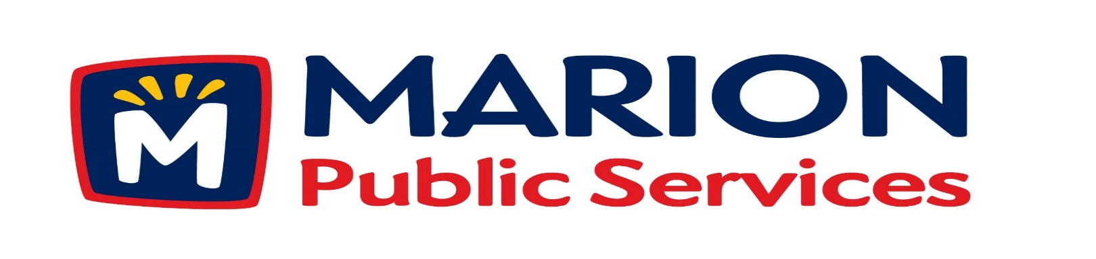
Minutes
Public Services Board
City of Marion
Tuesday, November 14th, 2017

Present: Craig Adamson, Colleen Prokop, Tom Padley, Kevin Morgan, and Mark Morgan arrived at 12:05
Absent: None
Staff: Ryan Miller and Diane Toy

- Approval of October 2017 Minutes.

- Motion to approve application for house pick-up service. (Carley- 1155 27th Street).
- Discussion regarding request for Qualifications for the Eco Industrial Park Phase I.
- Discussion regarding Wastewater Treatment Agreement with Cedar Rapids.
- Discussion regarding Public Service Department Objectives for 2018-2019.
- Old Business / New Business.
- Adjournment.
Minutes
Public Services Board
City of Marion
Tuesday, November 14th, 2017
Continued

ITEM 1 Approval of October 2017 Minutes.
Craig Adamson called to order the regular meeting of the Public Service Board on Tuesday, November 14th, 2017 at 12:00 PM. A motion to approve the October 2017 minutes was made by Tom Padley, seconded by Colleen Prokop, approved by all, Motion carried.

ITEM 2 Motion to approve application for house pick-up services.
Ryan updated the PS Board that the Carley’s have requested house pick up at their resident 1155 27th Street. Staff has gone out and spoke with them and have requested house pick-up, they are elderly and cannot get the garbage to the curb safely. A motion was made by Colleen Prokop, seconded by Tom Padley, approved by all members, Motion carried.

ITEM 3 Discussion regarding Request for Qualifications for the Eco Industrial Park Phase I.
Ryan updated the PS Board on the RFQ’s received for the Eco Industrial Park Phase I for a Construction Manager at Risk (CMAR). We received packets from 7 firms:
Acterra, Rinderknecht, Knutson, Miron, McGough, Estes and Mortenson.
We will send out and RFQ to the top 3 firms and make a final decision from that group.
Coralville is using the same format to build their newest project and other cities have used a CMAR for their projects. Mark wants to make sure that the correct information is communicated to the residents and staff, Ryan said the RFQ will have this listed that the company will have a communications person / Department in house or connected to them.
Ryan is working with the attorneys to finish up the RFQ, and will proceed to the next step.
Craig asked about background checks, the attorneys are working on this.
The grading is complete and we are waiting for core samples and we will be planting winter wheat as our ground cover. All PS Board members are ready to proceed to the next step.

Minutes
Public Services Board
City of Marion
Tuesday, November 14th, 2017
Continued

ITEM 4 Discussion reading Wastewater Treatment Agreement with Cedar Rapids.
Ryan has been in talks with Cedar Rapids for the last 6 years and we have finally come to agreeable terms of using Recommended Standards to calculate the fees billed to us each month. The fees are broken down into 2 parts waste water (monthly capacity charge) and O & M charges. We installed flow meters a few years ago to get accurate numbers on our usage to present to Cedar Rapids and shared the data with them. Ryan is also looking into how we bill developers for the sewer connection and may make some updates to how we bill them in the future. A motion was made by Craig Adamson to be updated on the progress of the discussion with Cedar Rapids on the Wastewater Treatment Agreement, seconded by Colleen Prokop, approved by all members, Motion carried.

ITEM 5 Discussion regarding Public Service Department Objectives for 2018-2019.
Ryan up dated the PS Board about the PS Board on the Strategic Planning session for the City held on November 11th, 2017, all the new council members were present and up to date on the plans for the city. The Strategic priorities for the coming year are: Zero waste, Lead planned growth, redevelop the Central Corridor into a Vibrant City Center, implement higher design standards, improve transportation system, including comprehensive trail system. , Ryan talked about the new organization chart for the city and new positions in City Hall as employees retire. We are looking at future endeavors within the whole City of Marion and make changes to help us grow. Ryan will keep the PS Board informed of the changes
Craig Adamson left the meeting at 12:45PM and Mark Morgan took over as Chair.

ITEM 6 Old Business / New Business
Old Maidrite Building has major structural problem. Knapp Wordan did a structural inspection and the building is fixable but very expensive, need to place scaffolding in place to protect pedestrians from falling brick.

Minutes
Public Services Board
City of Marion
Tuesday, November 14th, 2017
Continued

ITEM 7 Adjournment.
The meeting was adjourned at 1:15 PM by Mark Morgan. A motion was made by Kevin Morgan, seconded by Colleen Prokop, approved by all members, Motion carried.

Next PS Board meeting is scheduled for Tuesday, December 12th, 2017 at noon.

Respectfully submitted by:

____________________
Ryan Miller
Public Service Director

RM/dpt

