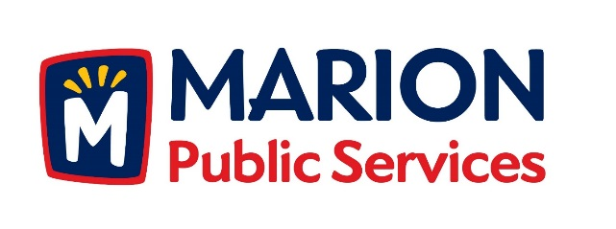

CITY OF MARION PUBLIC SERVICE BOARD
AGENDA
Noon
November 14th, 2017

- Motion to approve the October 2017 Minutes.

- Motion to approve application for house pickup services (Carley-1155 27th Street).

- Discussion regarding Request for Qualifications for the Eco Industrial Park Phase I.

- Discussion regarding Wastewater Treatment Agreement with Cedar Rapids.

- Discussion regarding Public Service Department Objectives for 2018-2019.

- Old Business/New Business.

- Adjournment.

