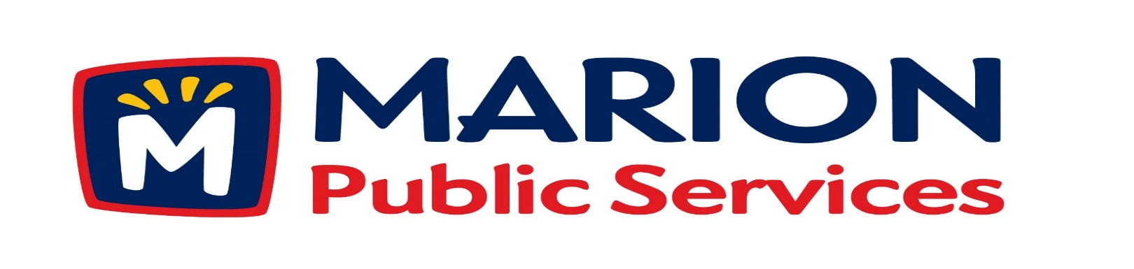

Minutes
Public Services Board
City of Marion
Tuesday, September 12th, 2017

Present: Craig Adamson, Colleen Prokop, and Mark Morgan
Absent: Kevin Morgan and Tom Padley
Staff: Ryan Miller and Debbie Weber

- Approval of August 2017 Minutes.

- Motion to approve House Pickup Request.
  - Armstrong-2730 11th Avenue
- Discussion Regarding Request for Qualifications for Contract Manager at Risk.
- Motion to Approve Request for Qualifications for Contract Manager at Risk.
- Discussion Regarding Structural Assessment Study for Signalized Intersections.
- Old Business / New Business.
- Adjournment.

Minutes
Public Services Board
City of Marion
Tuesday, September 12th, 2017
Continued

ITEM 1 Approval of August 2017 Minutes.
Mark Morgan called to order the regular meeting of the Public Service Board on Tuesday, September 12th, 2017 at 12:06 PM. A motion to approve the August 2017 minutes was made by Mark Morgan, seconded by Craig Adamson, approved by all, Motion carried.

ITEM 2 Motion to approve House Pickup.
Ryan updated the PS Board that the house pick up at 2730 11th Avenue the resident is elderly and cannot get the garbage to the curb safely. The Solid Waste Supervisor went to the residence’s home and has recommended the service for the resident. A motion was made by Craig Adamson, seconded by Colleen Prokop, all members agreed, Motion carried.

ITEM 3 Discussion Regarding Request for Qualifications for Contract Manager at Risk.
Objective is to find a good firm to handle the construction responsibilities of the new Eco Industrial Park. At the August Public Service Board meeting, members were briefed on various construction delivery methods for the first phase of the Eco Industrial Park. Staff and counsel has identified the utilization of a Contract Manager at Risk as the preferred method of delivery and has drafted preliminary qualification documents.

ITEM 4 Motion to Approve Request for Qualifications for Contract Manager at Risk.
A draft Request for Qualifications for Contract Manager at Risk services has been provided for
Board review. A formal by the Board will allow staff to proceed with City Council consideration. A motion was made by Craig Adamson, seconded by Mark Morgan to send out the Request for Qualifications for the Contract Manager at Risk, all members agreed, Motion carried.

Minutes
Public Services Board
City of Marion
Tuesday, September 12th, 2017
Continued

ITEM 5 Discussion Regarding Structural Assessment Study for Signalized Intersections.
On an annual basis, Public Service performs inspections signalized of intersections that include structural assessments of the poles and footings. The inspections include assessment of corrosive risk levels and structural integrity of the poles and footings with ultrasonic surveys. Recent reports have indicated that corrective action will need to be taken to address structural concerns of the traffic signal poles at specific intersections. Public Service has scheduled for additional surveys and inspections to be completed in order to recommend a course of action.

ITEM 6 Old Business / New Business.
- Discussion regarding the upcoming Annual Meeting for the Marion Chamber of Commerce to be held on 10/4/17. All Board members are invited to attend.
- An illustration of the new mast arm street markers was presented and reviewed.

ITEM 7 Adjournment.
The meeting was adjourned at 1:20 PM by Mark Morgan. A motion was made by Craig Adamson, seconded by Colleen Prokop, approved by all, Motion carried.

Next PSB meeting is scheduled for Tuesday, October 10th, 2017 at noon.

Respectfully submitted by:

____________________
Ryan Miller
Public Service Director

RM/dw

