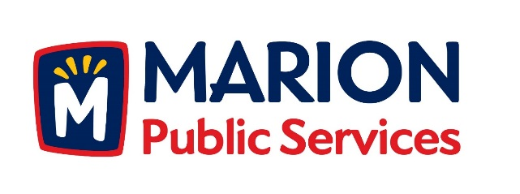

CITY OF MARION PUBLIC SERVICE BOARD
AGENDA
Noon
October 10th, 2017

- Approval of September 2017 Minutes.

- Motion to receive and file a request to waive collection fees for vacated premises (Burrack-3380 Sunburst Avenue).

- Motion to approve waiver of collection fees for 3380 Sunburst Avenue.

- Motion to receive and file request for seasonal sump pump mitigation (Lerch- 1080 Westview Drive).

- Motion to approve seasonal sump pump mitigation request for 1080 Westview Drive.

- Motion to receive and file request correspondence from Pheasant Trail Owners Association.

- Motion to receive and file proposals for commercial solid waste services.

- Motion to award contracts for commercial solid waste services.

- Update on Eco Industrial Park.

- Old Business/New Business.

- Adjournment.

