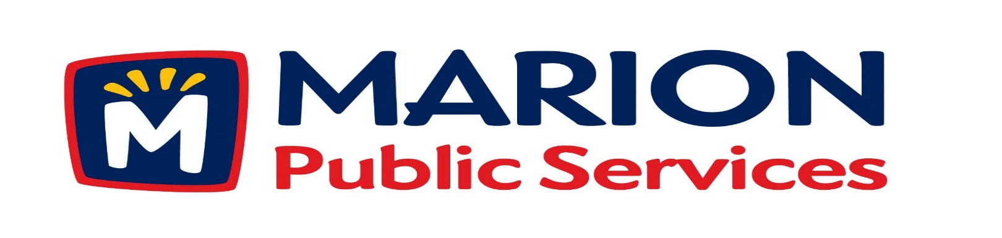

Minutes
Public Services Board
City of Marion
Wednesday, April 11th, 2017

Present: Colleen Prokop, Kevin Morgan, Mark Morgan, Tom Padley, and Craig Adamson
Absent: None
Staff: Ryan Miller and Diane Toy

- Approval of March 2017 Minutes.

- Motion to Approve the Public Service Work Schedule for 2017.
- Discussion Regarding Strategic Goals for the Public Services Department.
- Discussion Regarding Wastewater Treatment Agreement with the City of Cedar Rapids.
- Old Business / New Business.
- Adjournment.

Minutes
Public Services Board
City of Marion
Wednesday, April 11th, 2017
Continued

ITEM 1 Approval of March 2017 Minutes.
Craig Adamson called to order the regular meeting of the Public Service Board on Wednesday, April 11th, 2017 at 12:10 PM. A motion to approve the March 2017 minutes was made by Mark Morgan, seconded by Colleen Prokop, approved by all, Motion carried.

ITEM 2 Motion to Approve Public Service Work Schedule for 2017.
Ryan showed the PS Board the Public Service Work Schedule for 2017, right now Ryan works with the Supervisors on the work schedule, in the future he would like all staff involved. When making up the work schedule the 1st priority is citizen request that are checked out by staff, staff recommendations. The sweeping routes follow the plow routes, so areas with heavy sand are swept first. At this time we are down to one sweeper and are waiting for a rental unit. Cold patch maintenance follows the designated main routes and citizens requests, this shows we have a maintenance schedule. We follow a roadway grading schedule in the spring and fall. We do right of way maintenance beginning in the spring with the cleanup of heavy sand deposits on the right of ways of the designated snow routes. Personnel also collects debris and litter along the right of way in the spring as part of the continuing adopt a roadway beautification project. Full depth concrete patchwork has a current schedule along with a very aggressive schedule. The sewer sanitary box-out maintenance schedule we are trying to be more aggressive with this schedule. Ryan and staff are going to look into how the city handles street and curb maintenance. A motion was made by Tom Padley, seconded by Mark Morgan, to approve the request, all members agreed, Motion carried.

Minutes
Public Services Board
City of Marion
Wednesday, April 11th, 2017
Continued

ITEM 3 Discussion Regarding Strategic Goals for the Public Services Department.
Ryan talked to the PS Board about the department goals will be open to staff and PS Board for input. Administration goals: create a communications program for the department. Start construction on the Eco Industrial Park. Implement new employee training and safety programs. Introduce new professional positions into the PS Organization and facilitate re-organization of the department. Expand written operating policies for the flow of department operations. Ryan wants to work on employee strategic goals and seasonal work schedules. During the Strategic goals we can redefine what the PS roles are for the citizens and Ryan would like to hear from the PS Board on ideas. A motion was made by Mark Morgan, seconded by Colleen Prokop to move on with the strategic goals for the PS Department, approved by all, Motion carried.

ITEM 4 Discussion Regarding Wastewater Treatment Agreement with the City of Cedar Rapids.

Ryan finally received a new 28E agreement from the City of Cedar Rapids, it is the same as the one they worked on 2 years ago with the addition of added capacity charges of $9.2 million over 36 months, currently we have capacity of 34, 000 that we have been paying for years. Our monthly rate will decrease to $249,617.00 per month starting July 1st, 2017. Ryan suggested to the PS Board that we need to look at other options at this time and we need factual and feasible plan to move forward.
We need to look at all the facts and what we will need to rebuild the Squaw Creek truck line that will cost approximately $20 million to the Cedar Rapids sewer plant. The PS Board is not in favor of this 28E agreement, they want Ryan to look at other options. A motion was made by Mark Morgan, seconded by Craig Adamson to move that we look at other options, approved by all, Motion carried.

Minutes
Public Services Board
City of Marion
Wednesday, April 11th, 2017

Continued

Item 5 Old Business / New Business.
Ryan talked about the new building for Limolink out at Medco by the airport, will be one building to house the company.

ITEM 6 Adjournment.
The meeting was adjourned at 1:50 PM by Craig Adamson. A motion was made by Tom Padley, seconded by Kevin Morgan, approved by all, Motion carried.

Next PSB meeting is scheduled for Tuesday, May 9th, 2017 at noon.

Respectfully submitted by:

____________________
Ryan Miller
Public Service Director

RM/dpt

