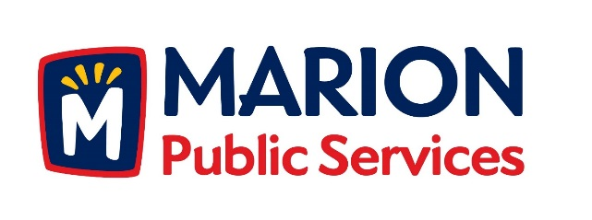

CITY OF MARION PUBLIC SERVICE BOARD
AGENDA
Noon
May 9th, 2017

- Approval of April 2017 Minutes.

- Motion to Approve House Pickup Request.

Larson-1235 Cardinal Drive

- Motion to Approve Revised Equipment Rates and Service Schedule.

- Motion to Approve Placement Agreement with Piper Jaffery.

- Discussion Regarding Design Services for the Eco Industrial Park.

- Old Business/New Business.

- Adjournment.

