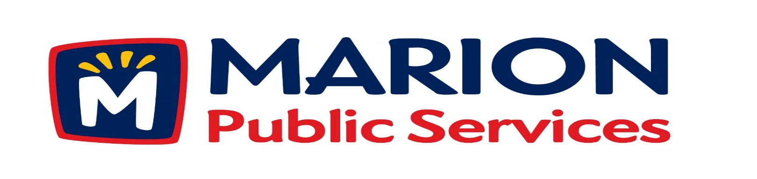

Minutes
Public Services Board
City of Marion
Wednesday, May 09th, 2017

Present: Colleen Prokop, Mark Morgan, Tom Padley, and Craig Adamson
Absent: Kevin Morgan
Staff: Ryan Miller and Diane Toy

- Approval of April 2017 Minutes.

- Motion to Approve House Pickup Request
Larson – 1235 Cardinal Drive
- Motion to Approve Revised Equipment Rate and Service Schedule.
- Motion to Approve Placement Agreement with Piper Jaffray.
- Discussion Regarding Design Services for the Eco Industrial Park.
- Old Business / New Business.
- Adjournment.

Minutes
Public Services Board
City of Marion
Wednesday, May 09th, 2017
Continued

ITEM 1 Approval of April 2017 Minutes.
Craig Adamson called to order the regular meeting of the Public Service Board on Tuesday, May 09th, 2017 at 12:15 PM. A motion to approve the April 2017 minutes was made by Mark Morgan, seconded by Tom Padley, approved by all, Motion carried.

ITEM 2 Motion to Approve House Pickup Request.
A request was made by a family member of Mr. Larson residing at 1235 Cardinal Dr for house pick up. The Solid Waste supervisor went out to visit the family and is recommending a house pickup starting on Friday, May 12th, 2017, A motion was made by Mark Morgan, seconded by Colleen Prokop, to approve the request, all members agreed, Motion carried.

ITEM 3 Motion to Approve Revised Equipment Rate and Services Schedule.
Ryan explained why we need to have an Equipment rate and service schedule. The Public Service Department are called to assist with accidents, concrete trucks that have a spill in the street, private contractor has a rock spill, hydraulic leak or other cities will ask for our assistance. We have readjusted our rates due to the FEMA reimbursement rate have changed. We are also encountering developers and sub-developers are not maintaining rock turn arounds to garbage and snow plow trucks and the placing of signs in new developments. Ryan is talking the City Manager and will bring it back to the PS Board about charging developers a fee up front for all the services the Public Service Department does, some of those services are televising sewer lines providing all street signs and installation.

Minutes
Public Services Board
City of Marion
Wednesday, May 09th, 2017
Continued

ITEM 3 Motion to Approve Revised Equipment Rate and Services Schedule continued.
We only charge for equipment with fuel cost included in the rate. Man hours are separate rate charged at 1 ½ times, the time is start to finish and includes travel time. Ryan is looking into set fees for developers. Craig asked that Ryan bring the schedule of up-front fees to the next meeting. Ryan also talked about the problem of occupancy permits are given before the streets, sewers, and water improvements are accepted and that causes problems because we have to collect the garbage and plow the streets if people are living in the homes. A motion was made by Colleen Prokop, seconded by Mark Morgan to accept the revised equipment rate and service schedule for the PS Department, approved by all, Motion carried.

ITEM 4 Motion to Approve Placement Agreement with Piper Jaffary
Ryan explained that he would like to retain Piper Jaffray to assist with the financial transactions with the Eco Industrial Park. The agreement will allow for financial analysis and due diligence of the proposed projects associated with the Eco Industrial Park. Services provided by Piper Jaffary will include financial and legal review of proposed project and coordination of closing and placement of financial transaction. If motion is approved by PS Board, Ryan will be taking it to the May 16th, 2017 City Council for approval. Wil be a motion and City Council approval for a grading bid to go out to contractors. A motion was made by Mark Morgan, seconded by Colleen Prokop to move that we approve placement agreement with Piper Jaffary and go out for the grading bid, approved by all, Motion carried.

Minutes
Public Services Board
City of Marion
Wednesday, May 09th, 2017

Continued

Item 5 Discussion Regarding Design Services for the Eco Industrial Park.

Ryan talked about finalizing the floorplan for the main building for the Eco Industrial Park. Ryan talked about Knapp Warden LLC - a full service architectural and structural engineering firm with experience across all sectors. Bill Knapp is a civil/structural engineer and partner in Knapp- Warden, LLC. His responsibilities include general office management and marketing of services. Bill is also responsible for design of all types of civil and structural projects including commercial, institutional, governmental, office and industrial projects. He has unique experience in bridge design and office buildings of all types. Bill also has extensive experience in providing construction management services for building projects. This experience provides a history of construction costing of recent building projects. Mike Warden is lead Architect and partner in Knapp-Warden, LLC. His responsibilities include general office management and supervision of drafting technicians. Mike is responsible for architectural design of all types of commercial, institutional, office and industrial projects. He has unique experience in sustainable design, health care facilities, restaurants and offices of all types. Knapp Warden is the best in experience and costs include structural engineering and architecture and they are a local company who specialize in steel buildings. Tom Padley went to school with Bill Knapp. We will sub-contract mechanical, electrical and plumbing. Next item will be a 3-D rendering of the floor plan.

Item 6 Old Business / New Business.
Ryan updated the PS Board that Solid Waste bag tags will cost $2.00 in August 1st, 2017, this has had one reading with the City Council so far and was pasted to have the next reading. This increase is due to the Solid Waste Agency increasing the cost for dumping fees.

Minutes
Public Services Board
City of Marion
Wednesday, May 09th, 2017
Continued

ITEM 7 Adjournment.
The meeting was adjourned at 1:28 PM by Craig Adamson. A motion was made by Tom Padley, seconded by Mark Morgan, approved by all, Motion carried.

Next PSB meeting is scheduled for Tuesday, June 13th, 2017 at noon.

Respectfully submitted by:

____________________
Ryan Miller
Public Service Director

RM/dpt

