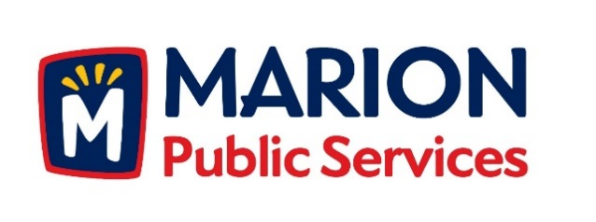

CITY OF MARION PUBLIC SERVICE BOARD
Item: Agenda
Date: June 13th, 2017
Time: 12:00pm

- Motion to approve the minutes for the May 2017 Public Service Board Meeting.

- Motion to receive and file correspondence from the Briargate Second Owners Association regarding maintenance of storm water detention basins.

- Motion to approve attachment and lease agreement with Verizon Wireless for installation of

- Discussion regarding infrastructure and maintenance fees for city sub-developments.

- Discussion regarding professional services agreement for Eco Industrial Park Development.

- Motion to approve grading plans and solicitation of bids for Eco Industrial Park Grading Package.

- Motion to recommend approval of professional services agreement with Knapp Warden for Eco Industrial Park Development.

- Discussion and update on Public Services Department and City of Marion activities.

- Adjournment.

