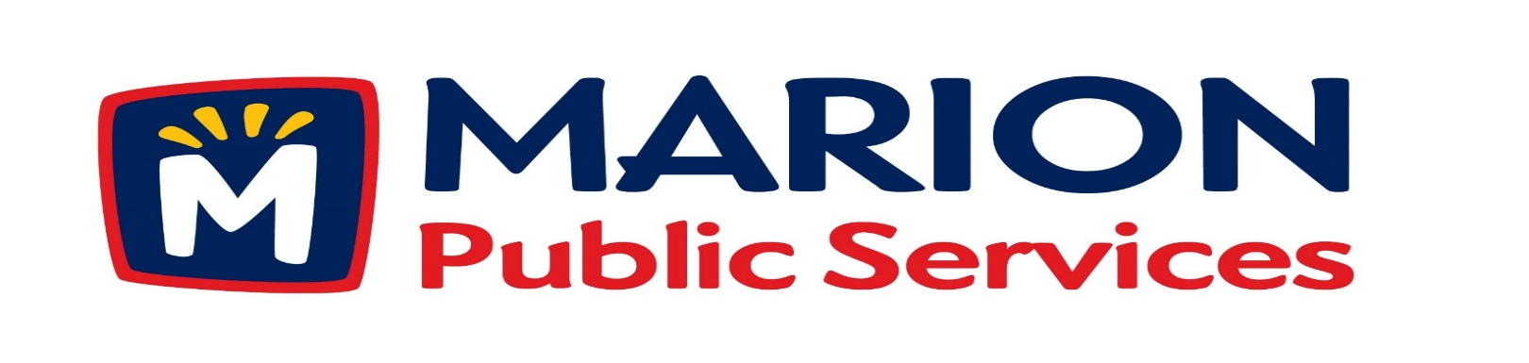

Minutes
Public Services Board
City of Marion
Wednesday, June 13th, 2017

Present: Mark Morgan, Craig Adamson, and Kevin Morgan
Absent: Tom Padley and Colleen Prokop
Staff: Ryan Miller and Diane Toy

- Approval of May 2017 Minutes.

- Motion to receive and file correspondence from Briargate Second Owners Association regarding maintenance of storm water detention basins.
- Motion to approve attachment and lease agreement with Verizon Wireless for installation of small cell antennas.
- Discussion regarding infrastructure and maintenance fees for city sub-developments.
- Discussion regarding professional services agreement for Eco Industrial Park Development.
- Motion to approve grading plans and solicitation of bids for Eco Industrial Park Development.
- Motion to recommend approval of professional services agreement with Knapp Warden for Eco Industrial Park Development.
- Discussion and update on Public Services Department and City of Marion activities’.
- Adjournment.

Minutes
Public Services Board
City of Marion
Wednesday, June 13th, 2017
Continued

ITEM 1 Approval of May 2017 Minutes.
Craig Adamson called to order the regular meeting of the Public Service Board on Tuesday, June 09th, 2017 at 12:09 PM. A motion to approve the May 2017 minutes was made by Mark Morgan, seconded by Craig Adamson, approved by all, Motion carried.

ITEM 2 Motion to receive & file correspondence from Briargate Second Owners Assoc. regarding maintenance of storm water detention basins.
Ryan updated the PS Board of the history of the basin, this is an Abode Addition and the basin was kept private and was maintained by the developer or HOA. Saratoga Dr. and 44th St off 29th Ave. is a new development with only one entrance into the development and with the heavy rain in April / May the detention basin overflowed and flooded 44th St. We did go out and clear the leaves so the water would drain. They are requested help, we have charged developers or HOA in the past to maintain the basins or help set up a maintenance program for them to do, What would the PS Board like to do? Craig would like to charge a fee up front and after the fees are collected we will maintain the basins, this would give us control on how they are maintained. He would like us to add Administrative fee and mowing cost. Mark feels if a private issue causes a public issue they should be fined. They should also deed / give the basin t the city. Per Ryan up to this point all private basins have not been maintained up to the city’s standards. Craig would like to have Ryan follow up on this with the PS Board. A motion was made by Mark Morgan, seconded by Kevin Morgan, to file and receive the letter, all members agreed, Motion carried.

Minutes
Public Services Board
City of Marion
Wednesday, June 13th, 2017
Continued

ITEM 3 Motion to approve attachment and lease agreement with Verizon Wireless for installation of small cell antennas.
Ryan explained the Verizon Wireless small cell antenna program to the PS Board. This is a 5 year lease program with Verizon to install the small cell on a new light pole that they install with City approval on location and then they pay a lease on the pole. We have done 6 build outs in the uptown area, we are adding fiber optics and maintaining the lights. By doing a lease agreement we will have control as to what the lights will look like, what is installed on them and where they are placed.
A motion was made by Mark Morgan, seconded by Kevin Morgan to move that we approve agreement with Verizon, approved by all, Motion carried.

ITEM 4 Discussion regarding infrastructure and maintenance fees for city sub-developments.
Ryan talked to the PS Board about fees for city sub-developers maintenance expenditures, now we bill after we perform and some developers are not paying the fees for the service. Some of the services we perform are sanitary and storm sewer inspection, sometimes we have to do this more than once. We also install street markers, stop signs, regulatory signs, post and have an installation charge. On streets that are a dead end have to have a rock turn around for garbage trucks and snow plows and they are not installed or maintained. PS board feels these fees should be charged up from with a penalty if not paid and escalation fee for each addition trip to televise. Ryan will get the cost with escalation and they discussed how to handle sign installation in new developments. This is a very time consuming task and we are not being paid by some developers for the signs and installation, Ryan talked about passing this task on to the developers with specs for signs and post with installation instructions. A motion was made by Mark Morgan, seconded by Kevin Morgan to set fees and pass the sign installation to the developers, approved by all, Motion carried.

ITEM 5 Discussion regarding professional services agreement for Eco Industrial Park.
ITEM 6 Motion to approve grading plans and solicitation of bids for Eco Industrial Park Grading Package.

Ryan explained that the City Council had approved the grading package for the Eco Industrial Park and Ryan wanted the PS Service Board to approve that we solicit the bid package to contractors. There is a large amount of dirt to be moved and we need to get this done so we can have the utilities installed. The have the CNG infrastructure installed and have the site ready for the CNG facility. A motion was made by Mark Morgan, seconded by Craig Adamson to move that we approve t agreement to go out for the grading bid, approved by all, Motion carried.

Item 7 Motion to recommend approval of professional services agreement with Knapp Warden for Eco Industrial Park Development.

Ryan talked about Knapp Warden LLC - a full service architectural and structural engineering firm with experience across all sectors. Bill Knapp is a civil/structural engineer and partner in Knapp- Warden, LLC. His responsibilities include general office management and marketing of services. Bill is also responsible for design of all types of civil and structural projects including commercial, institutional, governmental, office and industrial projects. He has unique experience in bridge design and office buildings of all types. Bill also has extensive experience in providing construction management services for building projects. This experience provides a history of construction costing of recent building projects. Knapp and Worden cost would be 3% of total cost of project excluding site work cost and an engineering fee of $15,000.00. By using a contract manager they work for you, get done what you want and stay within the budget of the project.
Grading should be done in 60 days with a $500.00/ day penalty after the 60 day deadline.

Item 8 Discussion and update on Public Service Department and City of Marion activities.
Ryan met with Ken Rizer about introducing new legislature to change the bill as written on how sewer rates are charged from Cedar Rapids to surrounding cities.
We have installed flow meters to monitor the flow from the Solid Waste Agency into the City of Marion’s sewer lines, they are self-reporting and the numbers do not match to what the flow meters are showing.
Co-Op Board – meeting and they will discuss if they want to move forward with the CNG station / project.
29th Ave is a full depth concrete patch.
Mark Morgan will be absent from the July and August meetings.

ITEM 9 Adjournment.
The meeting was adjourned at 1:40 PM by Craig Adamson. A motion was made by Mark Morgan, seconded by Kevin Morgan, approved by all, Motion carried.

Next PSB meeting is scheduled for Tuesday, July 11th, 2017 at noon.

Respectfully submitted by:

____________________
Ryan Miller
Public Service Director

RM/dpt

