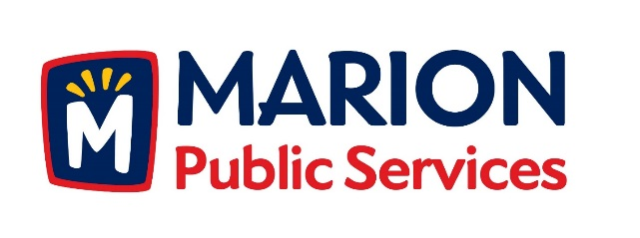

CITY OF MARION PUBLIC SERVICE BOARD
AGENDA
Noon
7/10/17, 2017

- Approval of June 2017 Minutes.

- Motion to Approve House Pickup Request.

-Pazour-1609 3rd Avenue

- Review of Citizen Claims.

-1890 Oak Creek Drive

- Motion to Solicit Requests for Proposals for Commercial Solid Waste Collection Services (Art in the Alley Project).

- Discussion Regarding Eco Industrial Park Phase II-Retail Fuels Station.

- Motion to Approve Fiber Optic Lease Agreement with Linn-Mar Community School District.

- Old Business/New Business.

- Adjournment.

